IN SEARCH OF THE HOLY GRAIL:

Reflections on a Visit to the Richard Wagner Festival in Bayreuth, Germany

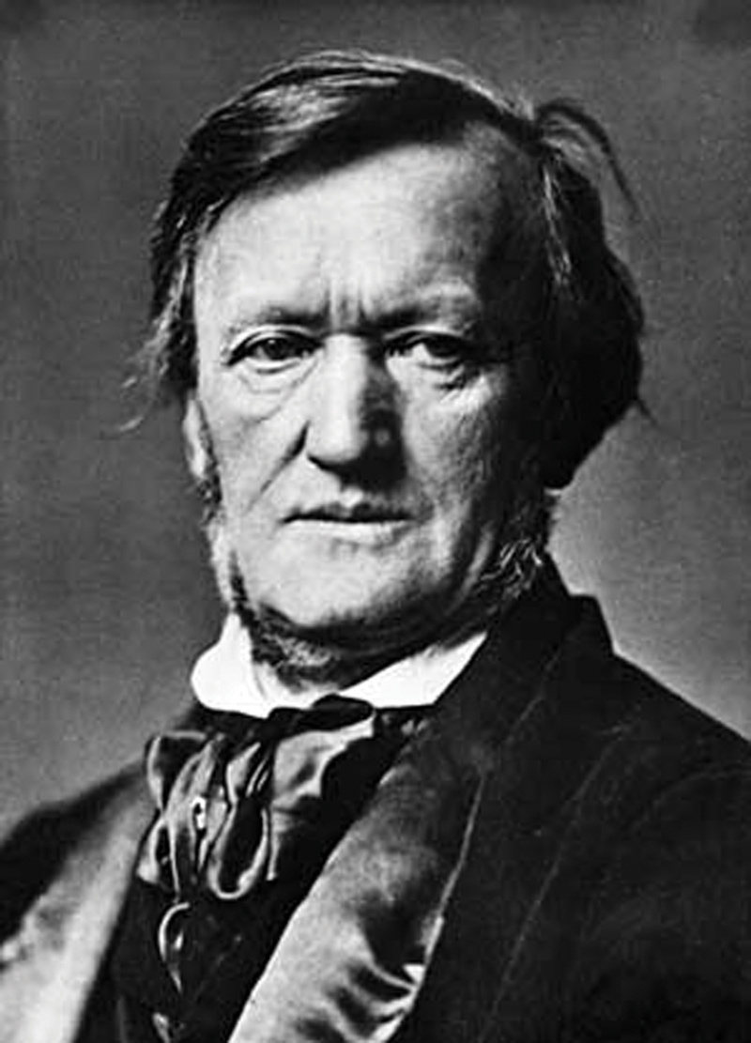
I have become fascinated lately with stories. It seems to me that only through story- telling can we weave together great truths in deeply meaningful, symbolic ways that communicate timeless essences and values. By choosing one story over another we decide which ideas are most important to us as a culture—which ones hold the richest ideas worthy of being passed to future generations. There are many sources of stories in every culture, but I believe we find some of the most powerful ones in religious myths, visual art, poetry, and of course, opera.

One story that has withstood the test of time, dating back to the 13th century, is that of the Holy Grail. As you will recall, from reading King Arthur or perhaps watching Monty Python, the Grail was the chalice used by Jesus at the last supper where he drank with his disciples, promising them a new covenant that would make heaven possible.

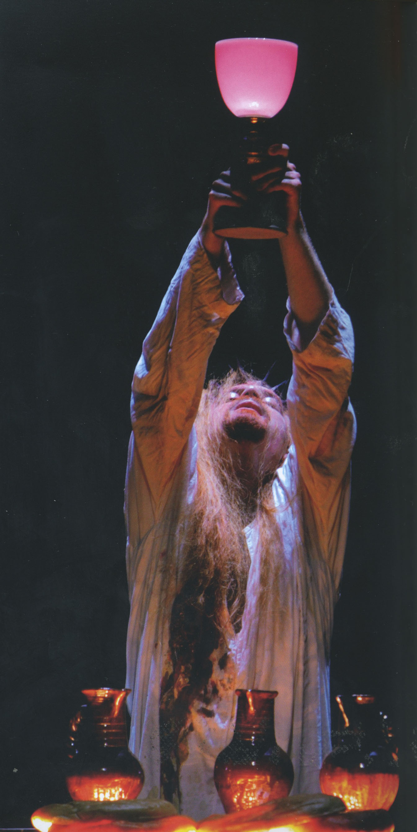 The perennial “search for the holy grail” has come to represent humankind’s constant search for the divine, the sacred—the desire to transcend ordinary reality and become united with our source, our origins, our God. On the surface, the search for the Grail is a story of an outer (physical) search—an attempt to find a sacred artifact. But the real meaning of the story lies in symbolizing the inward journey: the quest for spiritual transformation or connection to the sacred that every human strives toward regardless of specific religious belief.

For years I have had something of a religious devotion to the music of Richard Wagner, and always dreamed of hearing Wagner in the hall he had built in Bayreuth, Germany especially for performance of his music. In 2002 I began to look into the possibility of securing tickets to a Bayreuth performance because I decided it was simply something I had to experience. But there was one problem: I discovered that there are an astounding 500,000 tickets requested each year at Bayreuth with only 50,000 seats per year available. That made it nearly as difficult to get as Packer tickets. Why is this?

- Wagner himself designed the 19th-century hall especially for performance of his works
- The acoustics of the hall are world renowned
- The festival is able to attract the best of the best—directors, singers and conductors
- They offer cutting edge, sometimes controversial interpretations
- The festival performs only Wagner, and only during August each year

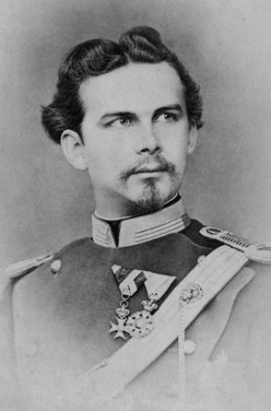 In the 1880s Wagner managed to convince the king of Bavaria, crazy King Ludwig II, to give him the funds to build his dream opera house. Ludwig loved Wagner operas, he had a great deal of money, and he built fantastic castles all over Germany, so he was a natural choice for Wagner. You may have seen one of King Ludwig’s other creations in Germany called Castle Neuschwanstein, which later became the model for “It’s a Small, Small World” at Disneyland.

Ludwig lived here for 6 months after it was completed before tiring of it and moving to another castle. He truly was crazy.

The opera house at Bayreuth, located 100 miles south of Berlin, was subsequently built to Wagner’s specifications that were state of the art at the time, and remains so to this day with many modern technological updates. The Bayreuth Festival is held over a 4-week period each summer, usually involving about 6-8 Wagner operas. No other composer’s music is ever played at Bayreuth. It has thus become something of a shrine for Wagner lovers, attracting people from all over the world. Although a beautiful structure in its own way, you can see that the Bayreuth Opera house was not quite as expensive or pretentious as the Neuschwanstein Castle. But it suited Wagner’s purposes perfectly.
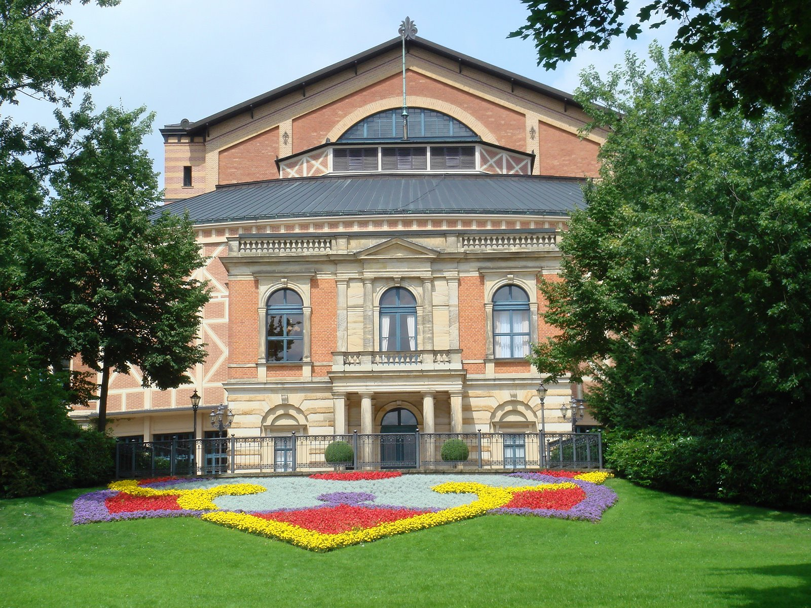
Armed with the knowledge that all it took was patience and money to receive my tickets to an opera performance at Bayreuth, I began religiously ordering my tickets in 2002, receiving my rejection notices a few weeks later. Here is the letter I received in 2004:

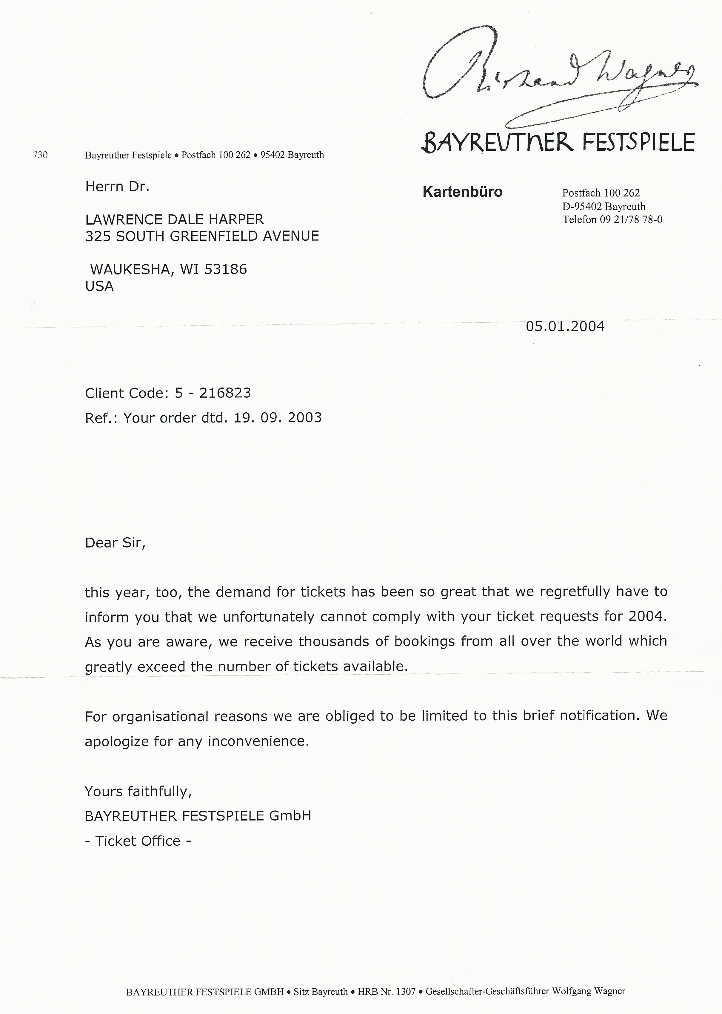
Then last fall, I moved. No order form arrived by mail, and I realized too late that I had missed the deadline. I was off the list, or so I thought. So I feverishly drafted a letter to Katherina Wagner, the current head of the festival and great grand-daughter of Richard (I was willing to go right to the top). I sent copies of nine years of rejection letters and begged her not to put me at the bottom of the list. I was flabbergasted to receive a reply a few weeks later from her office with instructions of how to write to the office for returned tickets. Then a few weeks after that, sure enough, I FINALLY received tickets to two of the greatest of Wagner’s works, Parsifal and Lohengrin (along with a $660 bill).

It’s interesting that both these operas involve stories of knights of the Holy Grail. Therefore, my long pursuit of tickets over a ten-year period AND my ongoing search for deep spiritual experiences in Art, seemed in some way to mirror the quests of the knights that I would be watching and hearing.

Preparation

As a preparation for hearing the 2 operas, I spent 2 weeks traveling through Germany; visiting Berlin, Leipzig, Dresden, Nuremburg, and Bamberg. I learned much about Germany history and Germans’ attitudes toward that history that helped to inform my understanding of Wagner and his operas.

My Wagner pilgrimage began in Leipzig, the city where Johann Sebastian Bach lived for over a quarter of a century. I was able to attend two performances and a church service in the same church where Bach served as cantor from 1723 until his death in 1750: the famous St. Thomas Kirche.
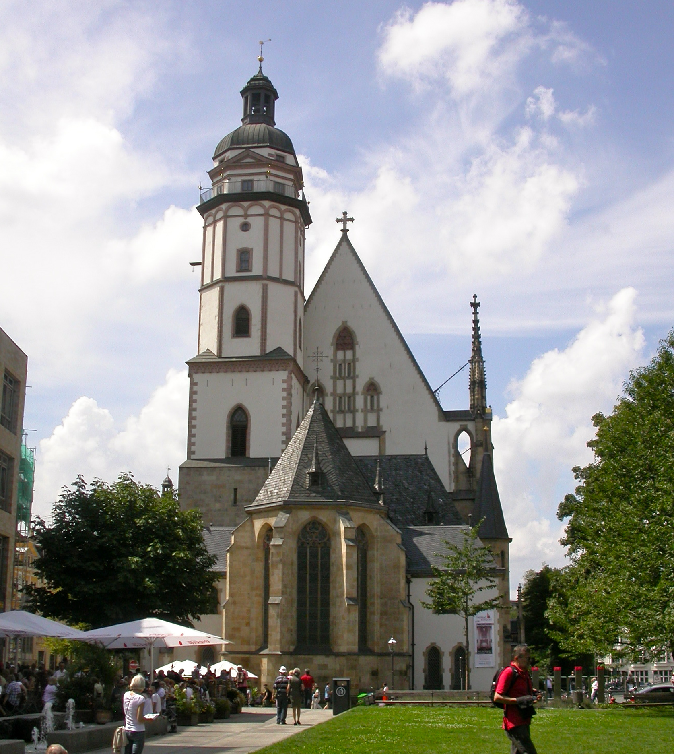Bach was responsible for writing music for St Thomas and the Nicolai Church of Leipzig
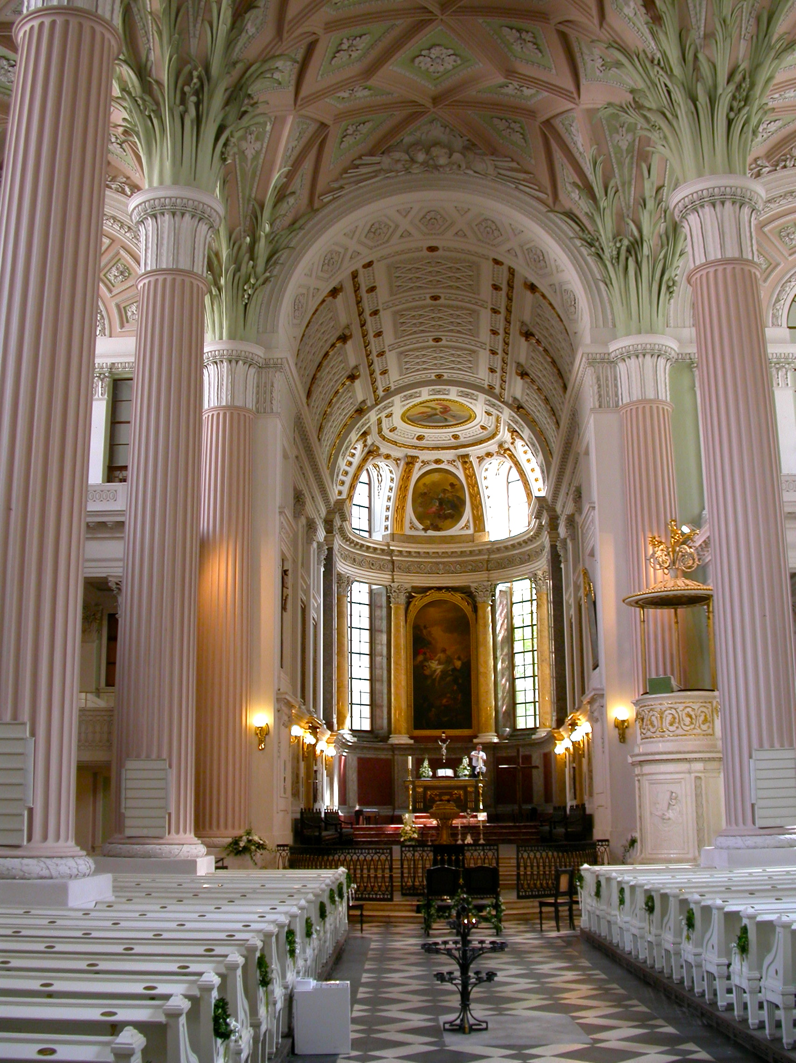 as well as the university church. Bach left us 209 cantatas for use in Sunday services, some of them lasting over 30 minutes. If you think you are busy, imagine Bach performing his duties at three churches in Leipzig, teaching at the Boy’s School, writing music (without computer), rehearsing for performances, recruiting players of which he was always short, and being a father to 21 children. He is buried (after being posthumously moved twice) under the altar inside St Thomas.
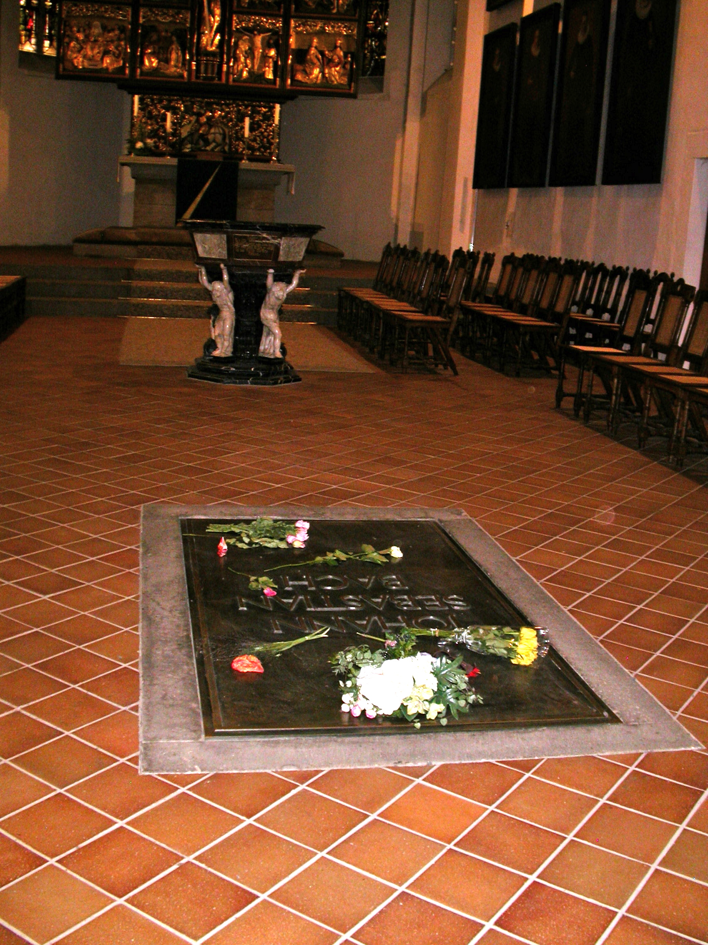
And his statue stands outside the entrance of the church.
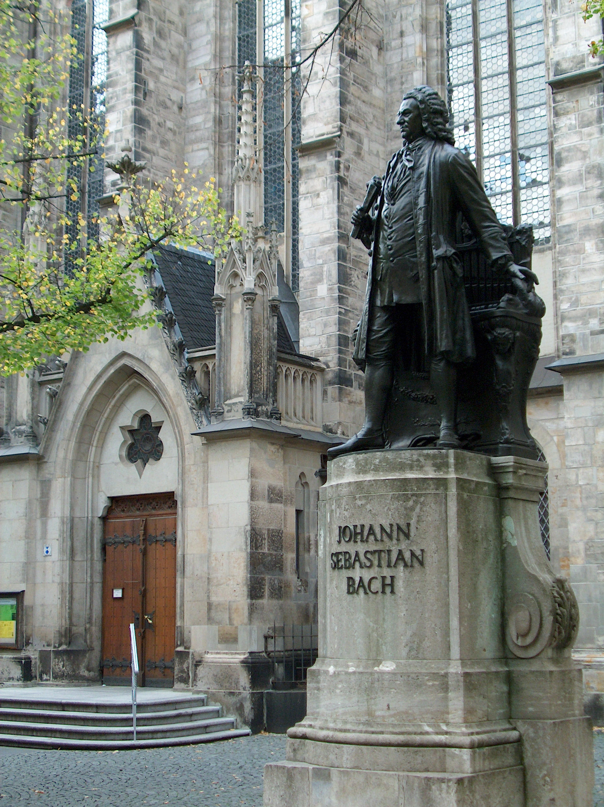
To roam the city of Leipzig, to breath the air where Bach, Mendelssohn, Schumann, Goethe, and many others spent long periods was especially meaningful and inspiring.

I traveled also to Dresden, surely one of the most beautiful cities in the world.

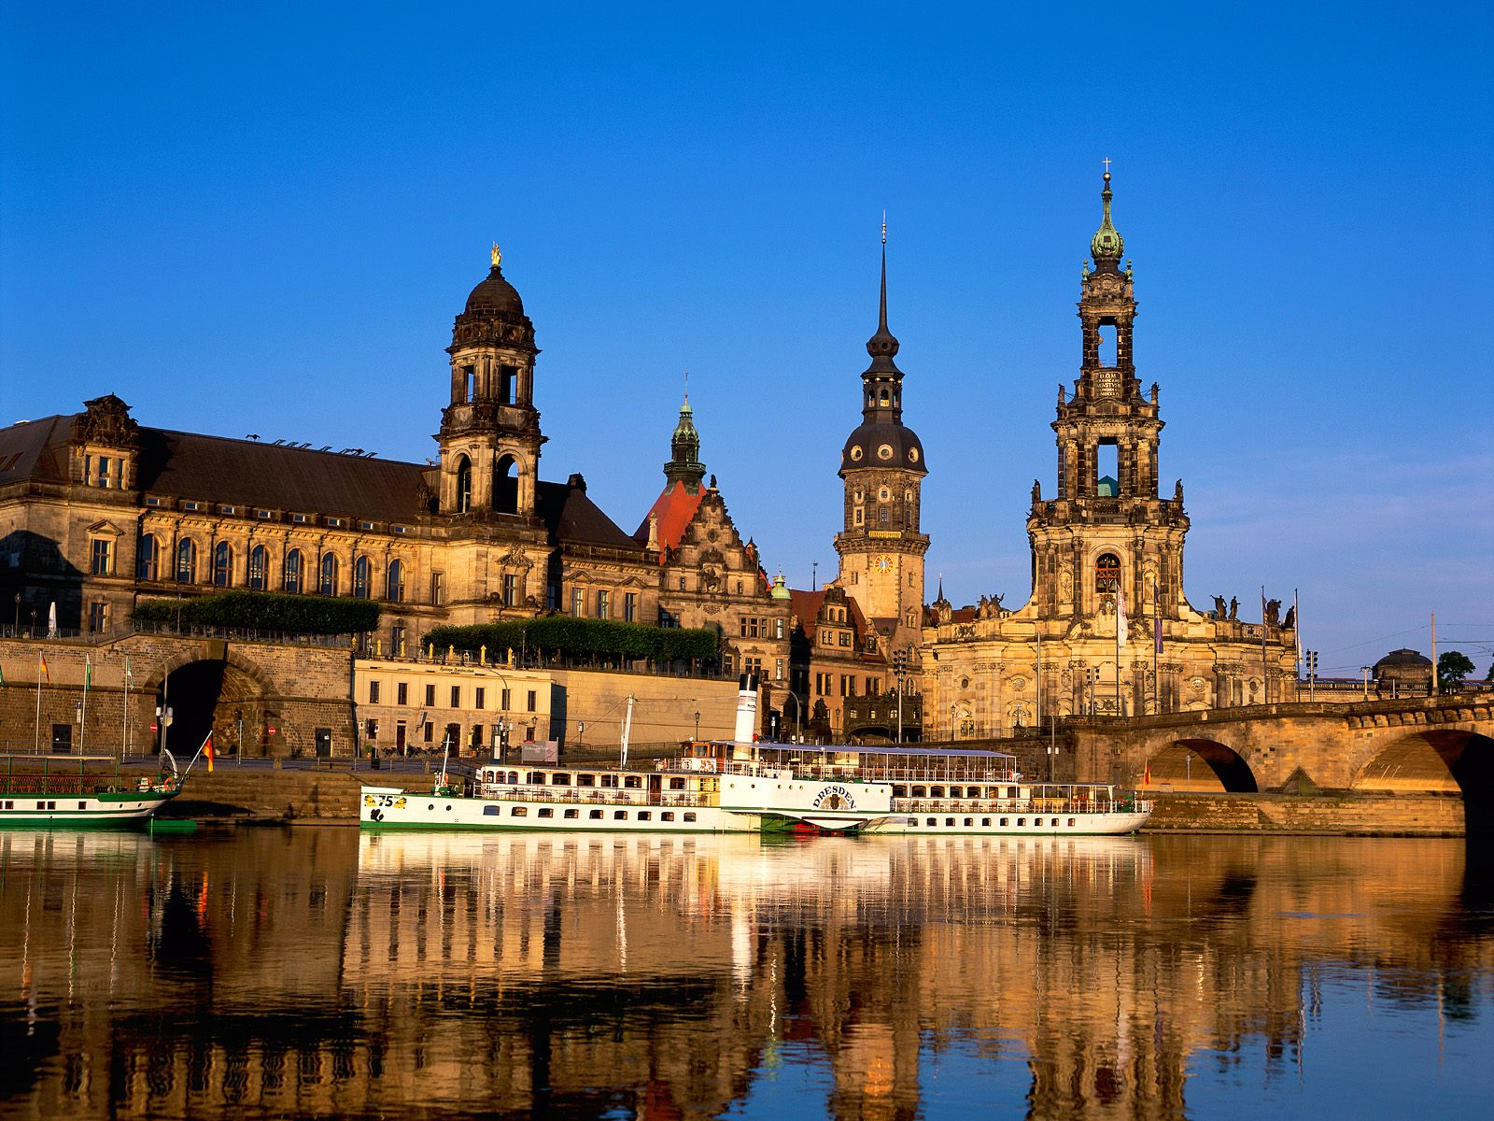

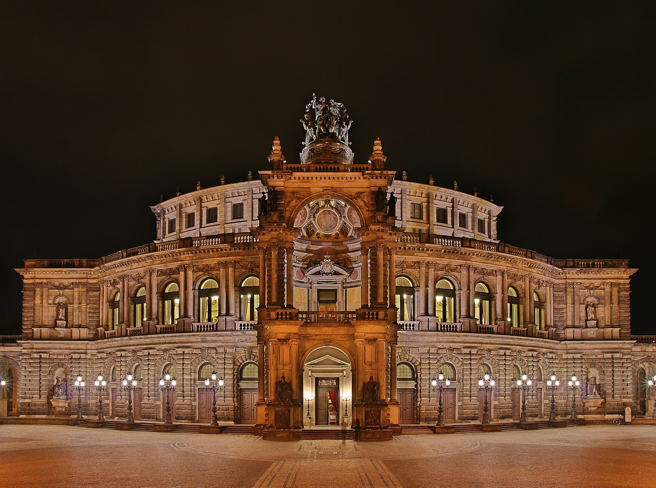
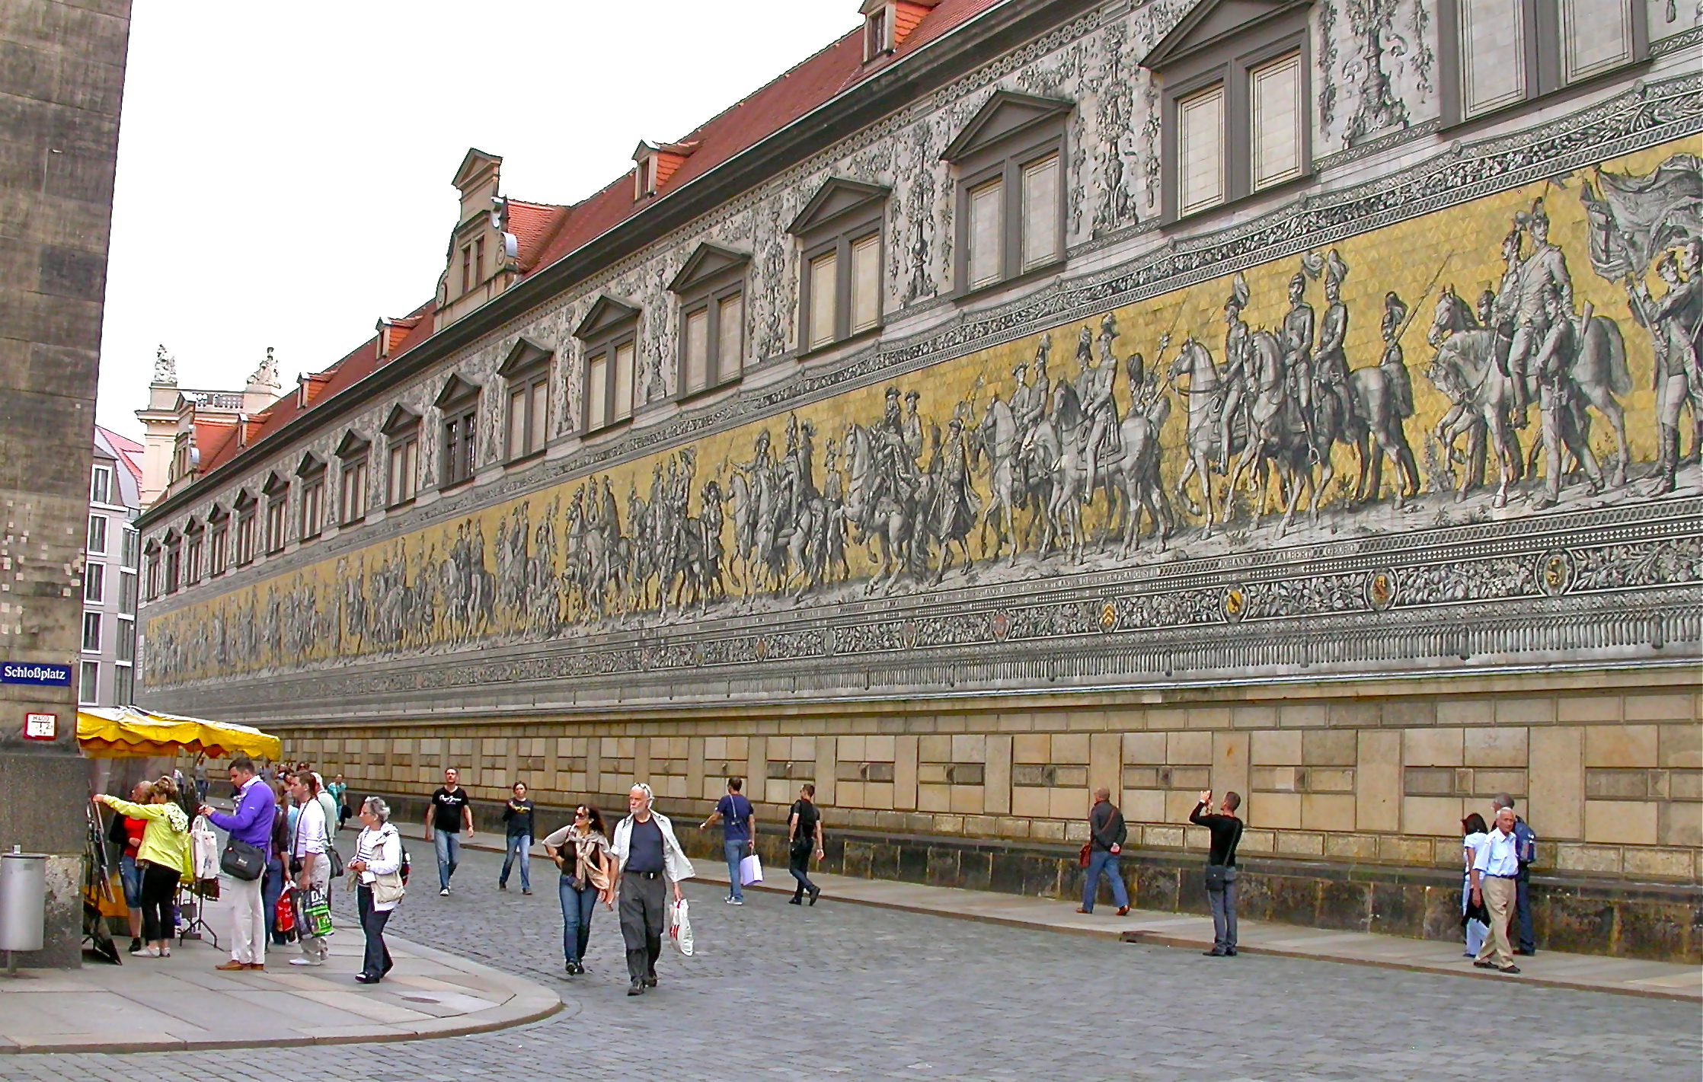Procession of the Dukes (95 leaders on horseback from the last 1,000 yrs, 25,000 ceramic tiles)

This city of Dresden provided the backdrop for one of the most haunting examples of the tragedy of war. Immortalized in Kurt Vonnegut’s Slaughterhouse 5, Dresden was completely wiped out during WW2. It’s heartbreaking to realize how much life and architecture was lost in such a beautiful place, and what price had to paid in lives and money to rebuild it.

Near the end of the war in 1945 allied forces led by the US used 3,600 planes to drop 650,000 bombs that completely obliterated 15 square miles of the city centre. 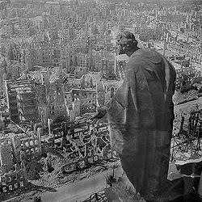 The bombing that took place there (and in Cologne, Hamburg, Bremen, Dusseldorf, Kassel, Mainz and many others), included incendiary bombs that set the rubble on fire, and created such high heat in the air that a firestorm was created: In a firestorm, oxygen is literally sucked up like a tornado into the upper atmosphere, including the air from any survivors’ lungs. Tens of thousands of civilians burned to death or were literally suffocated. Although the American government tried to defend the bombing by pointing to military targets outside the city, the evidence indicates it was a brutal strike against a civilian population. The bombing of civilians was immensely intensified during the war in an attempt simply to demoralize the population.

The central architectural masterpiece of the city, the beautiful Frauenkirche, like everything else, was wiped out.
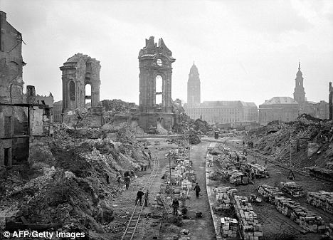

To the city’s credit, the Dresdeners meticulously rebuilt the city after the war in the old style, including the Frauenkirche that was just finished only in 2005, six decades after being destroyed.
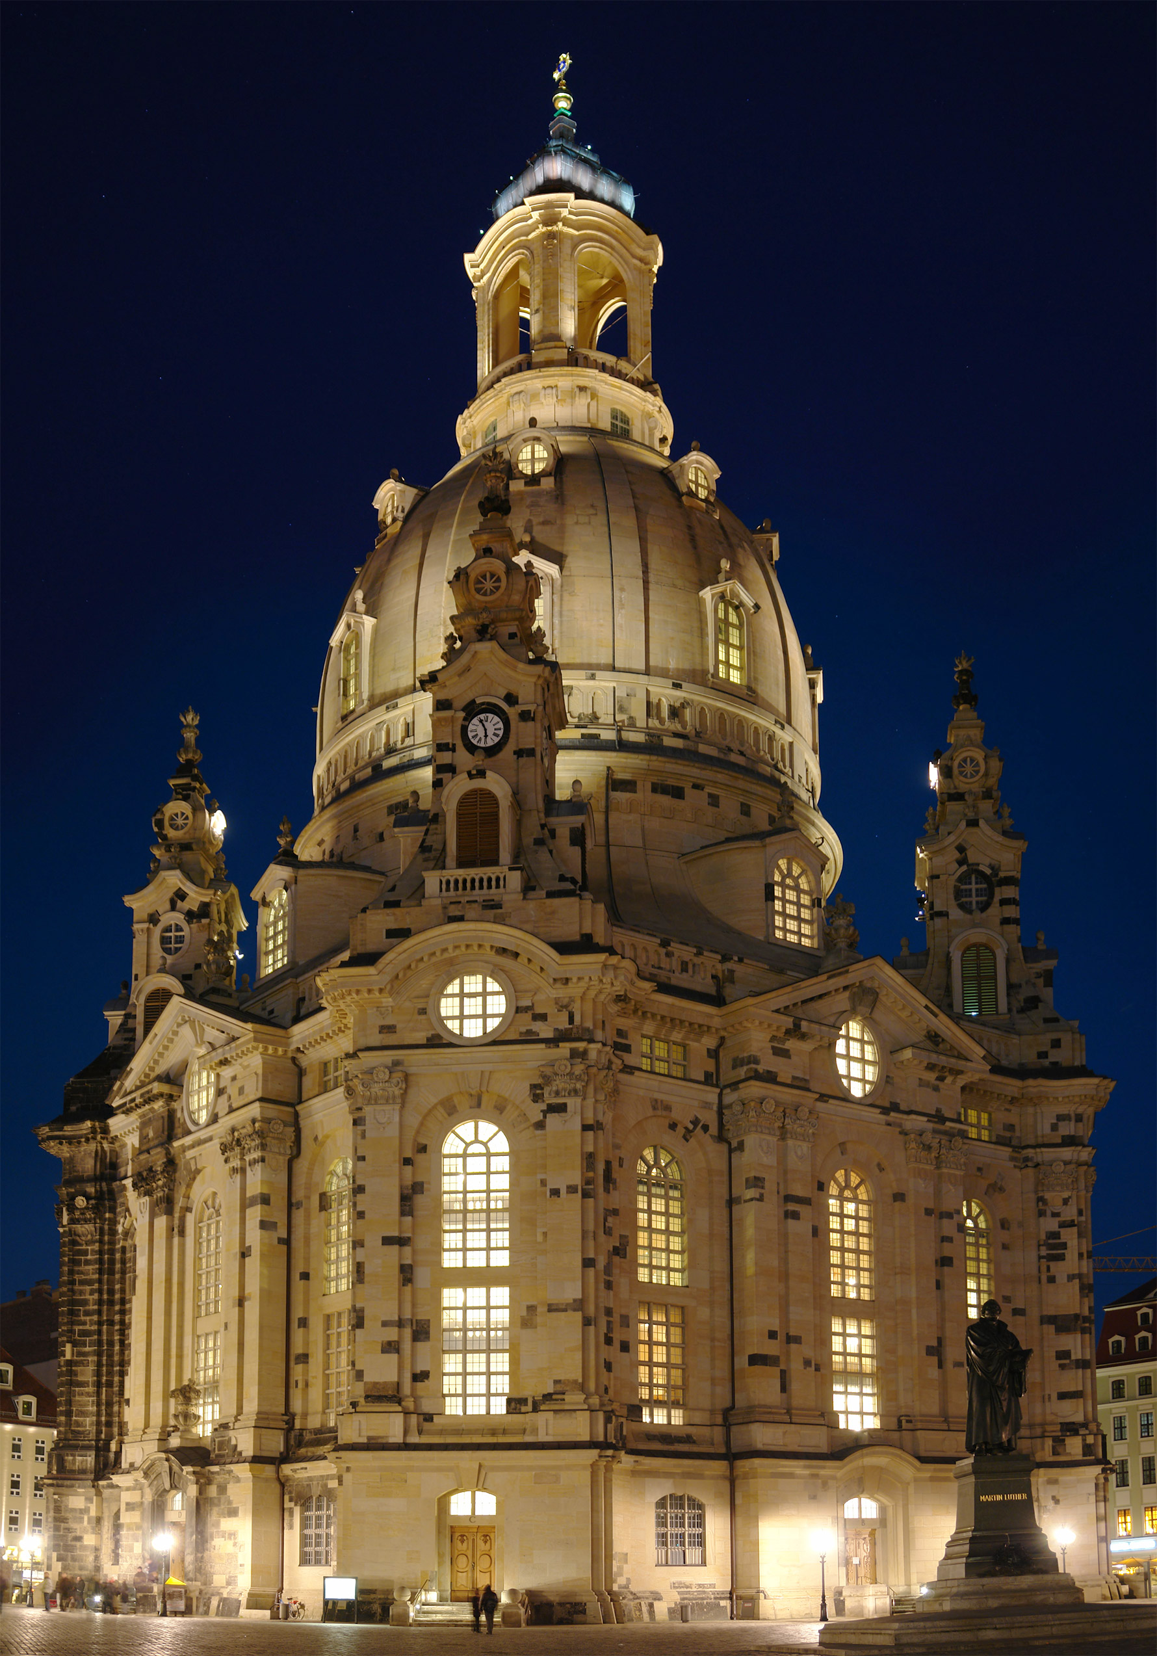 .

Nazi Germany

Of course, the German army and state police under Hitler’s leadership were also committing their own atrocities at the same time. It was impressive to me as I travelled through Germany, to see that the people there have gone to great lengths to make sure this is NOT forgotten. They recognize and hold up for analysis the reality that Nazism and ensuing mass genocide and war did indeed bring the world to the brink of Armageddon. I saw a large sign outside a small train station in Berlin that read: 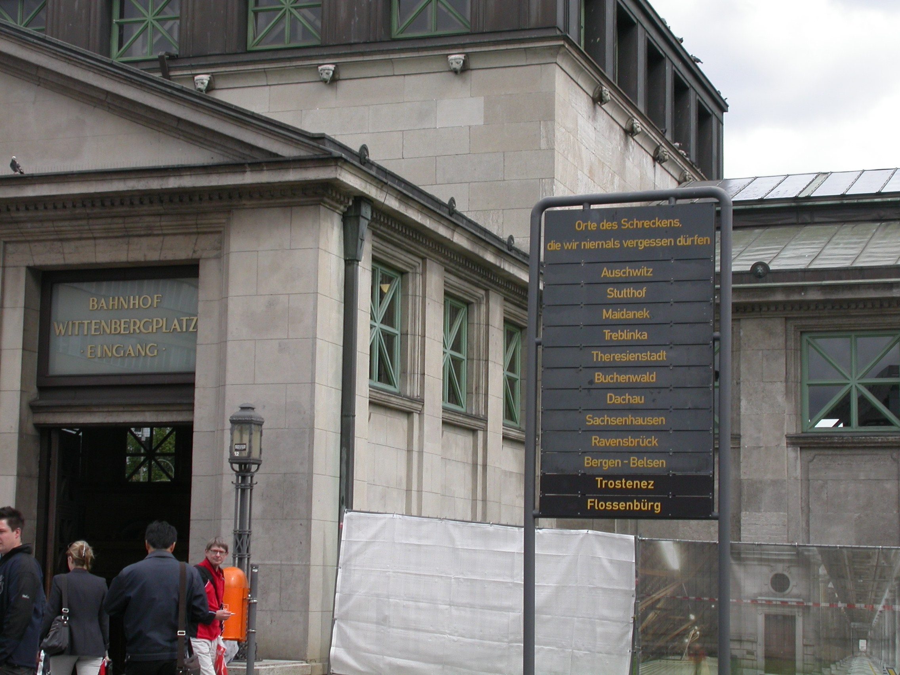“We shall never forget these places of terror,” followed by the names of several concentration camps.

I visited the Topography of Terror Museum in Berlin where the story of the SS was laid out in detail: how they terrorized and brutalized the Jewish population, homosexuals, and political enemies, all in the name of a strong, untainted and proud homeland. 6 million people were murdered at the hands of Nazis because they had a history and a set of beliefs that did not align with Hitler’s. Almost as disturbing as the camps was the way in which civilians were humiliated in public by being made to wear signs around their necks, or by public shavings of women who were suspected of having relations with Jews. (I saw the photos of these things) Hitler was able to turn people into things or numbers or sub-humans, making it easier to convince his men to murder them.

I travelled to Nuremburg to the Nazi rally grounds where there stands a huge unfinished amphitheater for party gatherings that’s nearly as large as a Roman Coliseum. There is also the outdoor Zeppelin Field measuring the size of three football fields on each side, large enough to hold 200,000 soldiers and a massive audience at one time. Here is the Zepelin Field in 1945…………..and the same structure today. They have preserved it as a reminder, however painful it might be.
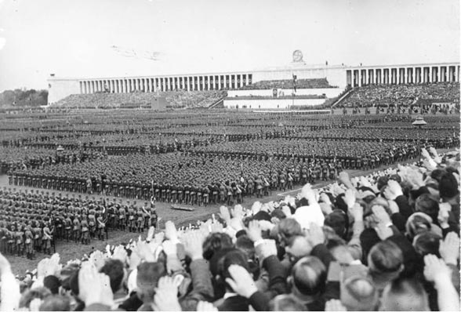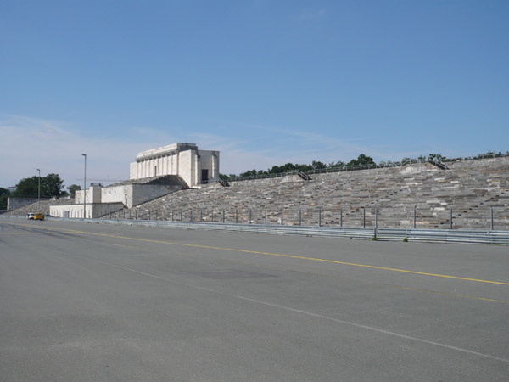

The rise of the Nazi party was told in several places that I visited. And each time, I was struck by how incrementally Hitler amassed his power and committed the atrocities. The Nazis constructed a hugely sophisticated system of dominance and intimidation and that is frightening in its sheer size AND level of competence. (That’s one of the frightening things to realize how brilliant these people were). It was done one small step at a time, nothing seeming that radical in itself. Furthermore, each step was always done in the name of Germany and for the honor and glory of the country.

Hitler was successful because he was a strong, charismatic leader who spoke unceasingly about the greatness of Germany and was able to bring prosperity to a country that was in severe economic decline. How many Americans would not want that kind of thoroughly patriotic president in these desperate times? Hitler tried to rid his country of people he found to be inferior to Germans, to keep the German race “pure.” How many Americans are fearful today of racial mixing from immigration or interracial marriage, and would readily embrace a policy of forced exile of those labeled as “inferior?” If those policies involved harsh treatment, I can see that many Americans would say it is a necessary evil. The separation between Germany of WWII and America may not be as great as we would hope, especially in harsh economic times.

How ironic that I was traveling to Germany primarily to hear Wagner, the composer that Hitler embraced above all others! Yes, Hitler absolutely idolized Wagner, and traveled to Bayreuth on several occasions for special performances for his SS officers. Here are two historic photos of Hitler at the opera house:
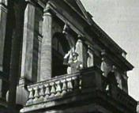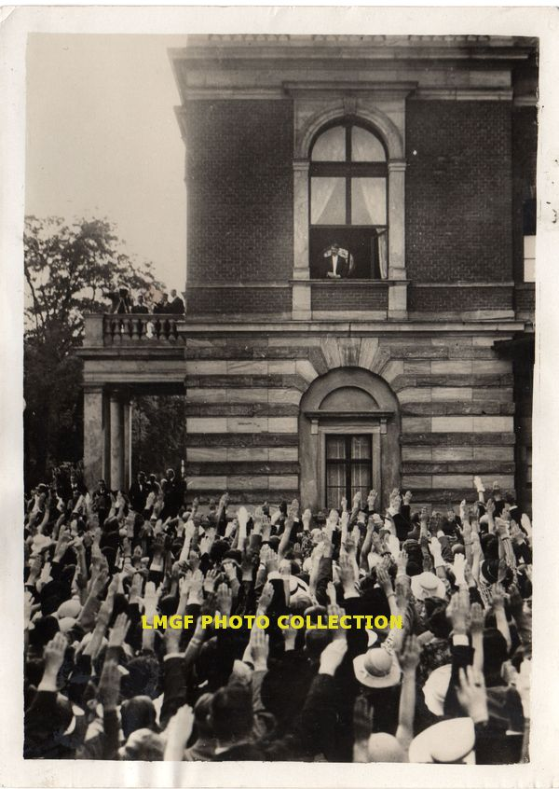

Hitler believed (as did Wagner) that Wagner’s music would re-establish the pre-eminence of German art in the world, unsullied by outside influences. But an even greater influence on Hitler was the fact that, decades earlier, Wagner had written virulent anti-semitic remarks on several occasions. It’s difficult to realize that the composer that wrote some of the world’s most sublime music also wrote the most hateful language against Jews. (It seems impossible!)

In a paper called Jewishness in Music, first published in 1850 under a pseudonym, Wagner wrote that Jewish music is bereft of all expression, characterized by coldness and indifference, triviality and nonsense. The Jew, he claimed, has no true passion to impel him to artistic creation. He accused Jews of being a harmful and alien element in German culture and stated the German people were repelled by Jews' alien appearance and behaviour. Wagner spoke of the (quote) "harmful influence of Jewishness on the morality of the nation," adding that the subversive power of the Jew stands in contrast to the German psyche. He even likened Jews to worms eating away at a body from the inside, and was clearly in favor of getting rid of Jews however necessary. We cannot escape the facts: while Richard Wagner died 6 years before Hitler was born, his influence on Hitler’s later National Socialist movement was enormous.

On the other hand, there are no identifiable anti-semitic ideas that appear in Wagner operas. It’s as if Wagner instinctively knew that this kind of thinking had no place in his art. Thus, the case of Wagner the man, embodies the extremes of human character, all in one individual—the sublime and the hateful—creating a true paradox. Once asked how he could love such a man as Wagner, Leonard Bernstein replied, “I hate Wagner—on my knees.”

It’s not difficult to see why a person like Hitler would embrace Wagner, knowing about Wagner’s belief in the primacy of Germany art and his hatred of Jews. How ironic, though, that Hitler embraced the composer of the Ring des Nibelungen. The main message of Wagner’s Ring (all 17 hours of it), is that an arrogant lust for power and wealth leads inevitably to Armageddon. In the Ring, Alberich steals the Rhine gold, and fashions a powerful ring of it by renouncing love. When the head god, Wotan, steals the ring from him, Alberich curses it. All who possess the Ring thereafter meet with tragedy. Alberich’s curse of course still haunts us today: Who would question that Wall Street bankers renounced love as they were raking in the gold during the housing foreclosure crisis? Hitler’s lust for power and wealth did lead to a twilight of mankind where the world came perilously close to disintegrating (witness Dresden). Yes, the story of Hitler and Wagner is the most remarkable example I know of life imitating art, or even more poignantly, of life failing to heed the lessons that art teaches us. We ignore these stories at our peril.

Bayreuth

The first obligation upon arriving in Bayreuth was to visit the Wagner house where the composer lived the final years of his life, and where he is buried. The place was named by Wagner, “Wahnfried” (interestingly translated as “free of delusions”).

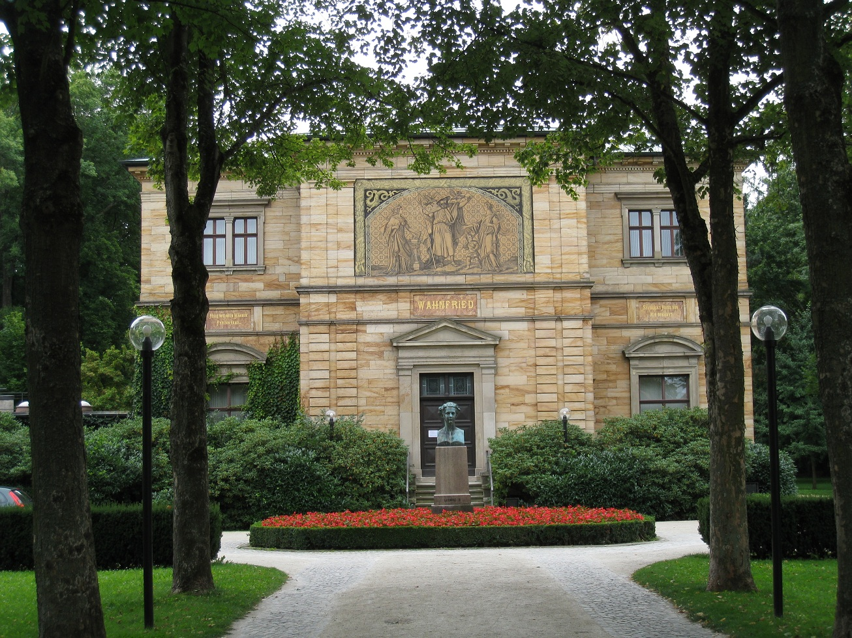

Wagner Grave:
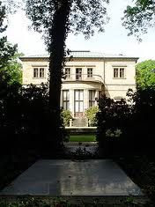
Wagner wanted the Bayreuth Opera House to be a special experience unique in the world and he went to great lengths to create it. To enhance the feeling of a pilgrimage, he located the hall in a small, out-of-the-way town that has no other remarkable features. Sitting on a hill, overlooking town, with a single road progressing up toward it, we find the ideal location for an opera house. It is a structure that is beautiful and noble but not elaborate. Wagner wanted the performance itself to stand above everything else and remain the sole point of concentration—no distractions. This is the photo I took as we drove up the hill and I saw the building for the first time:
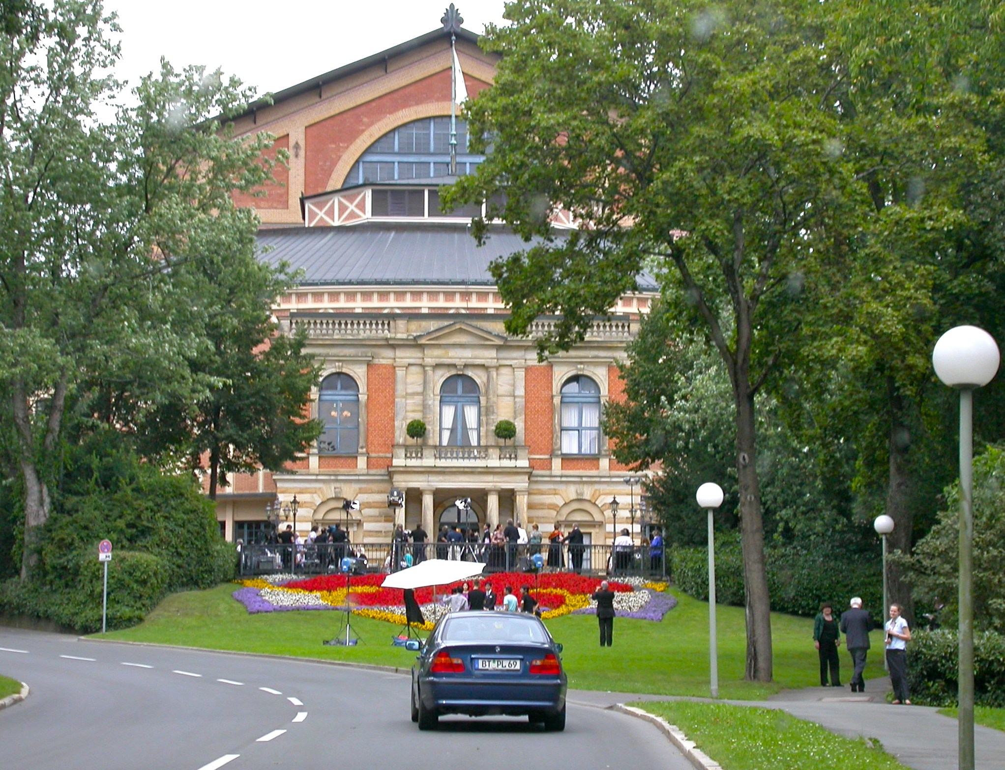

Performances at Bayreuth begin at 4 pm in the afternoon, and each of the three acts is separated by a one-hour break. Patrons dress primarily in formal evening attire even though they arrive mid-afternoon. A short brass fanfare extracted from the opera is performed from the balcony once at 15 minutes prior to the performance, twice at 10 minutes, and three times at 5 minutes prior. Lasting in most cases less than 10 seconds, these fanfares are immaculately performed and are eagerly anticipated, forming part of the lore of Bayreuth. The fanfare brass stand exactly where you earlier saw Hitler standing on the balcony.

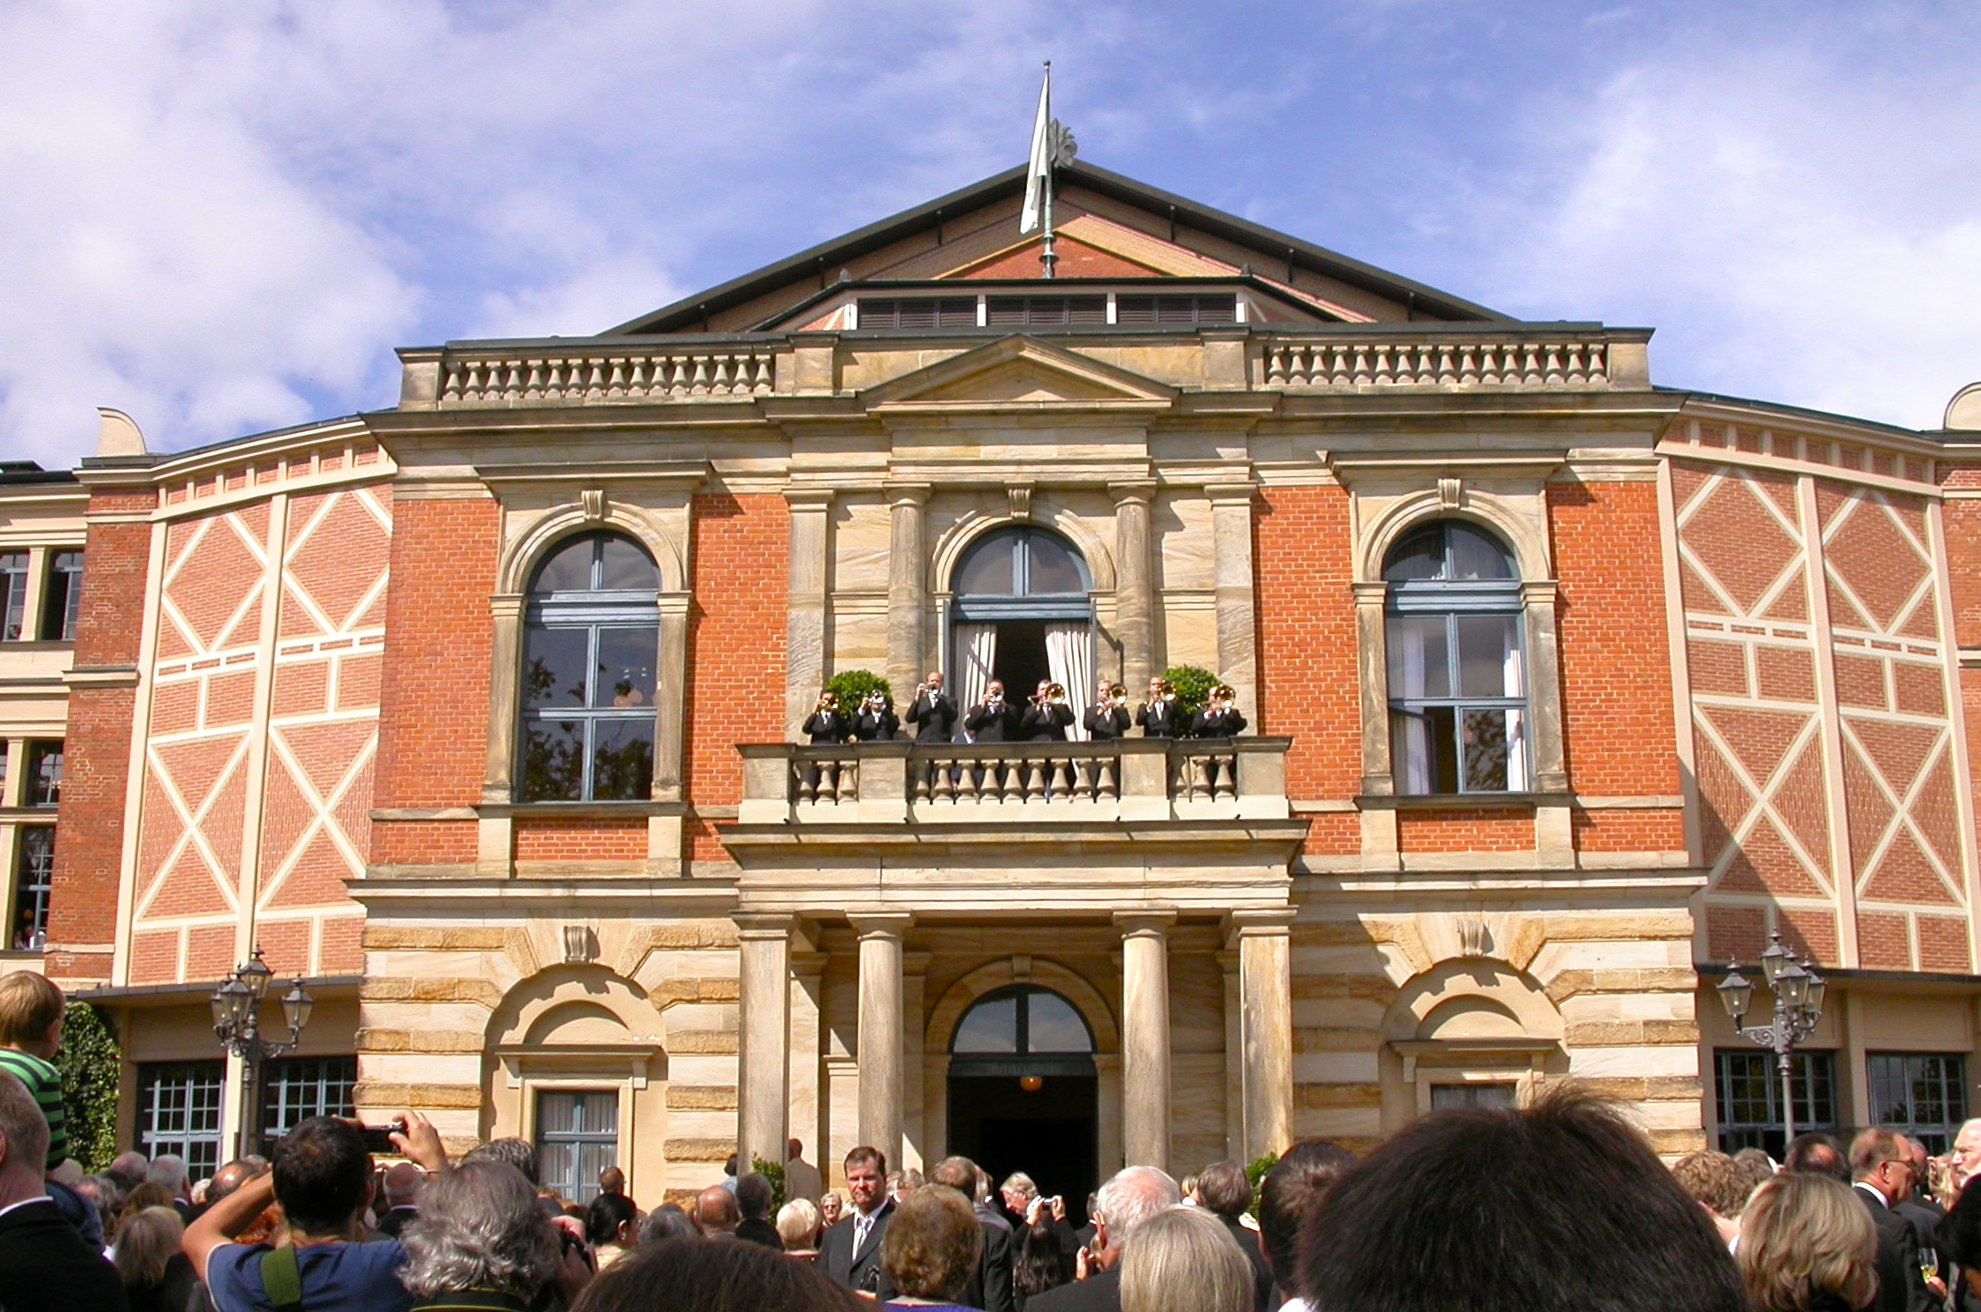

The inside of the hall is unique in design. It seats about 2000 and is constructed so that the stage action receives your entire attention. This is emphasized powerfully with receding columns that really focus the eye. The steeply raked seating, in a long semi-circle, with perfectly placed seats, allows for unobstructed views of the stage, and no seat is very far removed from the action: an ideal setting in every way.
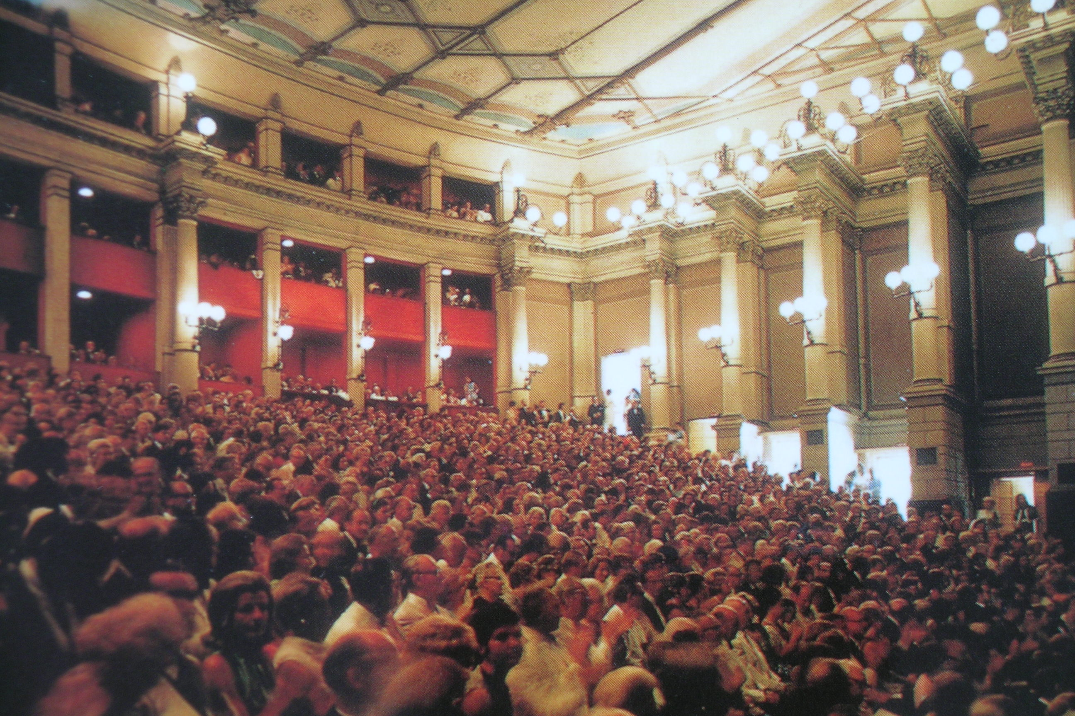

Most strikingly, there is no visible orchestra pit. This has the advantage of avoiding any distraction from seeing the orchestra or conductor. Although huge, the pit is sunk beneath the stage and is almost entirely covered by a reflecting sound shield. Sound is cast out toward the audience and also back to the singers. As a result, the orchestra never overwhelms the singers, creating a perfect synthesis of voices and instruments.

At the same time, the orchestra has a presence that is unlike any other hall in the world. The strings shimmer and blend seamlessly, the woodwinds sound with immense clarity, as if they are right in front of you, and the brass (located far below stage) can play with their heroic Wagnerian heft without covering the voices. The whole orchestra seems to arise from the ground itself with an aliveness and blend that is wholly captivating and thrilling.

Wagner envisioned that his operas would be a perfect amalgamation of vocal music, orchestral music, theater, scene design, drama, storytelling, and choreography. He called this new art form by the wonderful German word, Gesamtkunstwerk, meaning “total work of art.” The acoustics, history and setting at Bayreuth allow them to achieve a more unified and convincing synthesis of all these elements of a Gesamtkunstwerk than anywhere else in the world.

Lohengrin

Lohengrin was the first opera that I heard there. It relates the story of the Knight of the Holy Grail that arrives by swan (yes, a swan) to defend the honor of Elsa of Brabant, who has been wrongly accused of her brother’s death. Here are the main characters, the two female leads dressed as swans in opposing mirror images.
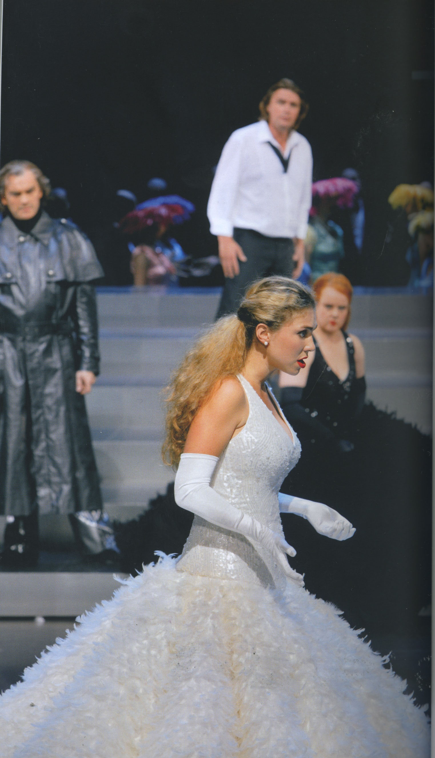

Upon arriving in Brabant, Lohengrin falls immediately in love with Elsa and proposes marriage. Since he comes from the Knights of the sacred order, the only thing he asks is that Elsa never ask his name or where he is from. He of course wants her to love him as a man, and not as a Knight of the Holy Grail. So the plot really centers around the idea of honesty and trust in a relationship. A perfect kind of love/trust proves to be an unattainable, Utopian dream however. The seeds of doubt are sown in Elsa’s mind by the power-hungry Ortrud, and Elsa eventually succumbs to the urge to know the Knight’s name. When finally forced to reveal his name and who he is, he must leave Elsa and Brabant and return to the Grail castle, leaving Elsa broken. The perfect love is not to be.

The paradox of course is that deep trust is essential in a relationship; but how can you truly know a person unless all is revealed? Can you love without fully knowing him/her? These are profound questions with no easy answers. But in Wagner’s rendition, long-term love does not seem possible because of this evident tension between trust and knowledge. Indeed, Wagner called Lohengrin his saddest opera.

The story may be depressing, but the music of Lohengrin is some of the most inspired and uplifting that Wagner ever wrote. I have always loved the opening music of the prelude, but hearing it in the perfect acoustic of Bayreuth was tremendous. The strings just glowed in the opening passage in their highest range, creating the aural equivalent of the Utopia sought by the characters. But here in the opening it so beautiful that perfection does indeed seem possible.

http://www.youtube.com/watch?v=4GbN-k7MHCc&feature=youtu.be

Two voices (Ortrud sung by Petra Lang and Lohengrin sung by Klaus Florian Vogt) were of a caliber I have never heard before and constitute superstars that will undoubtedly have long and hugely successful careers. Ortrud not only dominated Elsa (her lusty and aggressive kiss of Elsa is a memorable moment);
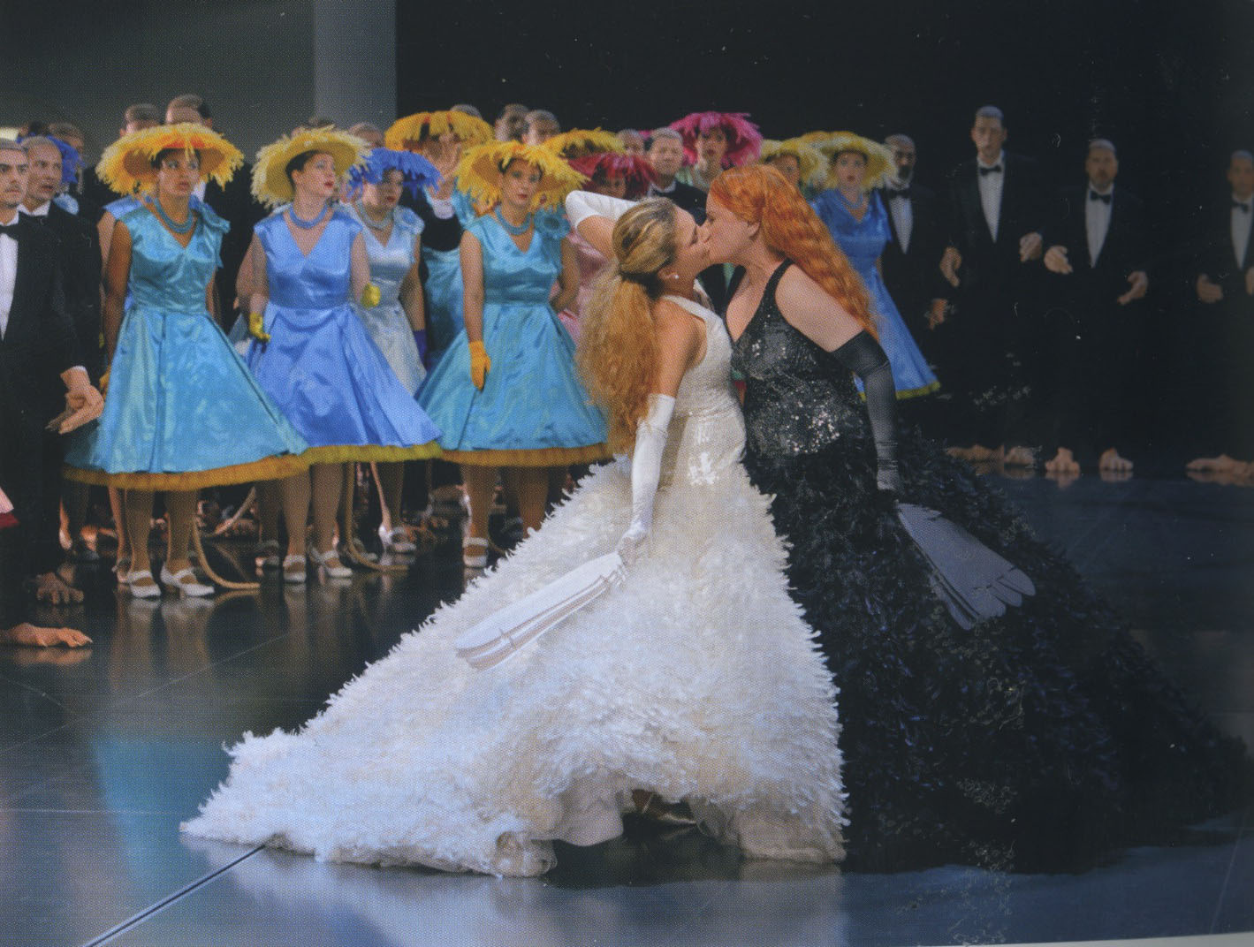she also dominated us in the audience. When she was onstage she completely captivated your attention with her mere presence, and her voice was oozing with hatred and envy and grief at every moment. This is always amazing to me how someone can just appear and with their posture, stature, and demeanor, totally engage your attention.

http://youtu.be/r_GEi41VyNk

Lohengrin had the most beautiful and lyrical tenor voice, with complete control throughout his range. Most impressively, when revealing his true identity as a knight of the grail, he sang alone in spotlight mid-stage with a barely perceptible “piano” that was really stunning.

http://youtu.be/tF0hi1XtOJw

Productions at Bayreuth do not follow the 19th century stagings that Wagner would have mounted in his day. The sets and dress are a combination of contemporary and traditional character, with a surreal edge to them that makes it difficult to pin them to one particular time period. The expression becomes much more universal and almost dreamlike in presentation. For example, a striking image from Lohengrin is the way the chorus is dressed. In most stage settings they are dressed as the town nobles, counts, and soldiers as described by Wagner. But in this production they appear in rat costumes, complete with face- mask, rat-like paws, and long tails. It is a jarring image at first that takes some adjustment. But then you realize that these are the folk that blindly follow the leader whether for food, power, money, land, or a variety of other “rewards.”

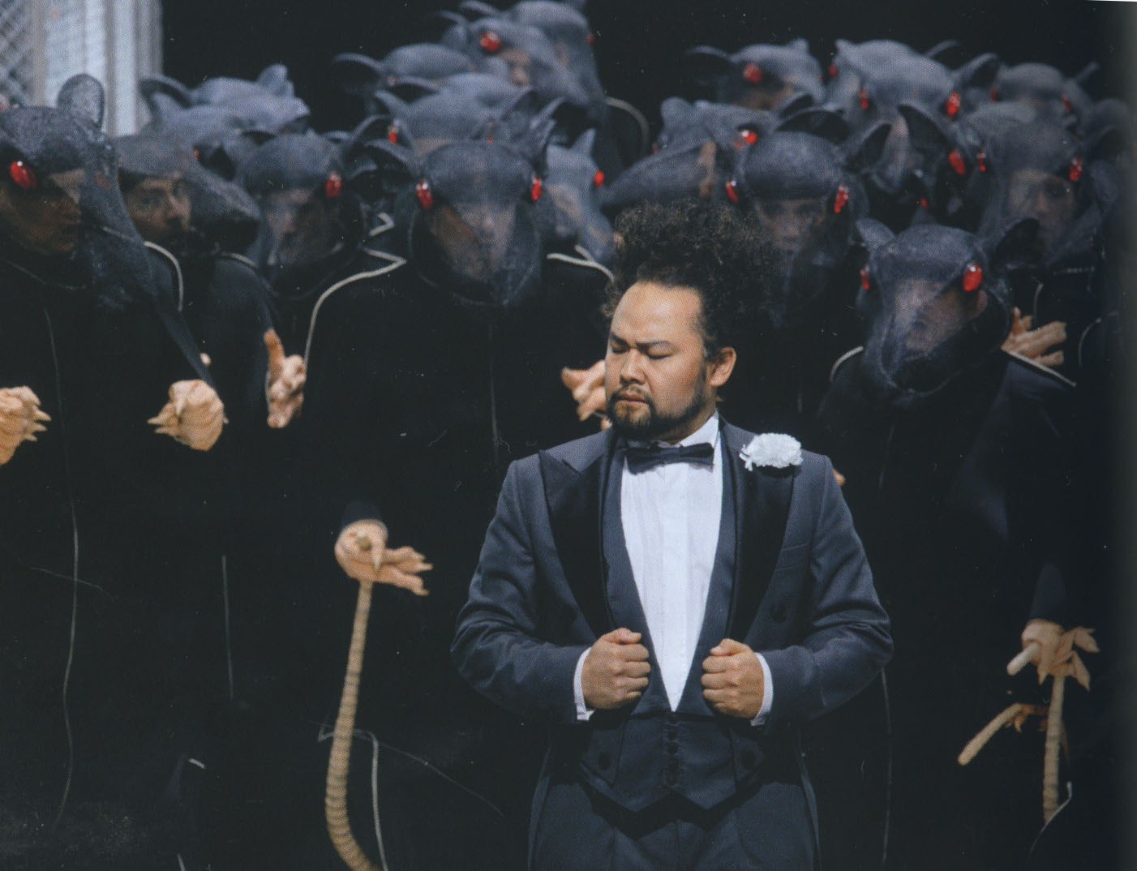

The huge orchestral ending of the opera comes as Lohengrin begins to walk back to Montsalvat, in this case directly toward the audience. The orchestra concludes the music of the opera, but he continues to walk toward you for several seconds, in complete silence.

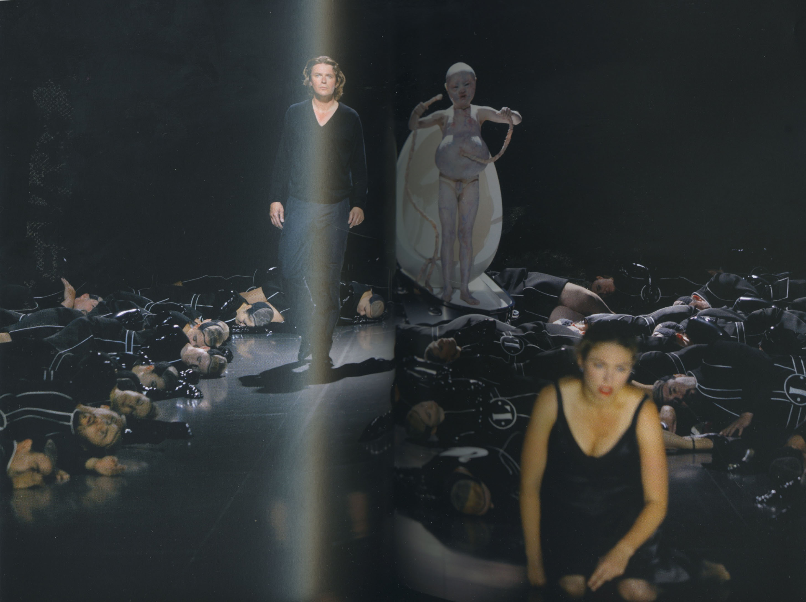

Complete silence in a hall with 2000 people is very powerful. This is a moment that could not happen in very many other houses in the world, though, especially in New York where audiences typically clap before the music even ends. It’s as if Lohengrin walks out of the theatrical world directly into your own world, because of course, his journey is our journey. We all experience this conflict in our relationships and must face the consequences of our decisions dealing with it, even if our view of love may not be as pessimistic as Wagner’s.

The curtain calls for the singers went on for nearly 20 minutes, and I left euphoric.

Parsifal

Less than 24 hours later I was back on the hill at the opera house to hear Parsifal. For many years the Wagner family attempted to keep Parsifal performances restricted to Bayreuth, but eventually conceded that that world deserved to hear it in other places as well. This exclusive history, along with the Christian and Buddhist overtones of the opera and the fact that it was Wagner’s last work, have given Parsifal performances at Bayreuth a special, sacred flavor and ambience. As one example, traditionally the audience does not applaud at the end of Act I, maintaining a reverent silence for what they have just witnessed. Near the end of the Act, following the sacred ritual of revealing the Holy Grail onstage, Gurnemanz asks the question of the naïve Parsifal, “Do you know what you have seen?” You sense that Wagner is asking you, the viewer, if you indeed know what YOU are seeing and hearing. Or, are we the naïve Parsifal who has no consciousness of the world around him? Has not fully engaged in it nor realized its potential?

This opera, like all stories, has numerous external events. But its significance lies in what is revealed about the internal human experience. The opera describes for us the journey of the spirit that every soul goes through. Just as summer inevitably gives way to winter, or the light fades at the end of each day, the soul goes through a journey into darkness followed by struggle to reach back into the light. The opera carries all the spiritual weight of a mass, funeral, or marriage, presented with heartbreakingly beautiful music and a reverential staging befitting the most solemn of occasions.

The plot is rich with meaning: The King of the Knights, Amfortas, through his own human failings, has suffered a Christ-like wound in his side that will not heal. (How many people do we know who have received a similar symbolic wound that will not heal.) (And who would deny the wound that WWII inflicted on Germany?) A naïve boy appears at the gates of the castle and witnesses the sacred ritual of the revealing of the Holy Grail. But he is not ready to understand the power of the sacred as yet, and he is sent out into the world to learn and experience. There he encounters the seductress, Kundry. He is able to resist her temptations and then travels the world on a quest for enlightenment. Years later he returns to the grail castle, now a mature man, with the sacred spear to heal Amfortas’s wound and return the knights to health and dignity. Parsifal undergoes a transformation that allows him to become a healer and visionary leader.

The Knights of the Holy Grail represent a sacred order that inspires our respect. But their rigid belief system and unwavering path result in dogma. In a documentary called the “Ascent of Man,” the author Jacob Bronowsky claims that it was not gas or bullets that killed 6 million Jews: Dogma killed them—the assertion that there is only one right way. In the film, Bronowsky visits the Auschwitz Concentration Camp where his ancestors had died. He walks into a puddle of water in the middle of the camp, crouches down in the water and says that “one of the great human dilemmas is the betrayal of the human spirit, the assertion of dogma that closes the mind, and turns a nation, a civilization, into a regiment of ghosts—obedient ghosts, or tortured ghosts”…. He then reaches down into the water and scoops out a handful of mud from the ground containing his ancestors’ remains and continues: “We have to touch people,” he says. Oliver Cromwell said it best when he wrote, “I beseech you, in the bowels of Christ, think it possible you may be mistaken.” If the Grail Knights slipped into dogma, how easily might we?

At the beginning of the opera, the knights’ castle appears to be located in the back of Wagner’s house, Wahnfried, with the prompter’s box doubling as his gravesite. It’s an indoor setting that mysteriously appears also to be outside the house. (perhaps symbolizing inward and outer experience simultaneously).

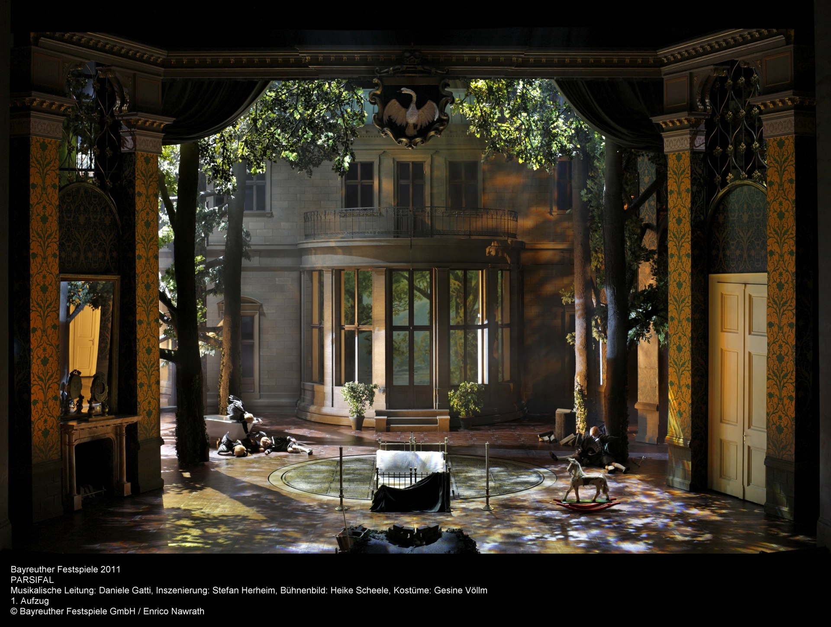

The Bayreuth Parsifal makes a direct connection between the Grail Knights and Hitler’s Germany when Nazi storm troopers appear onstage:
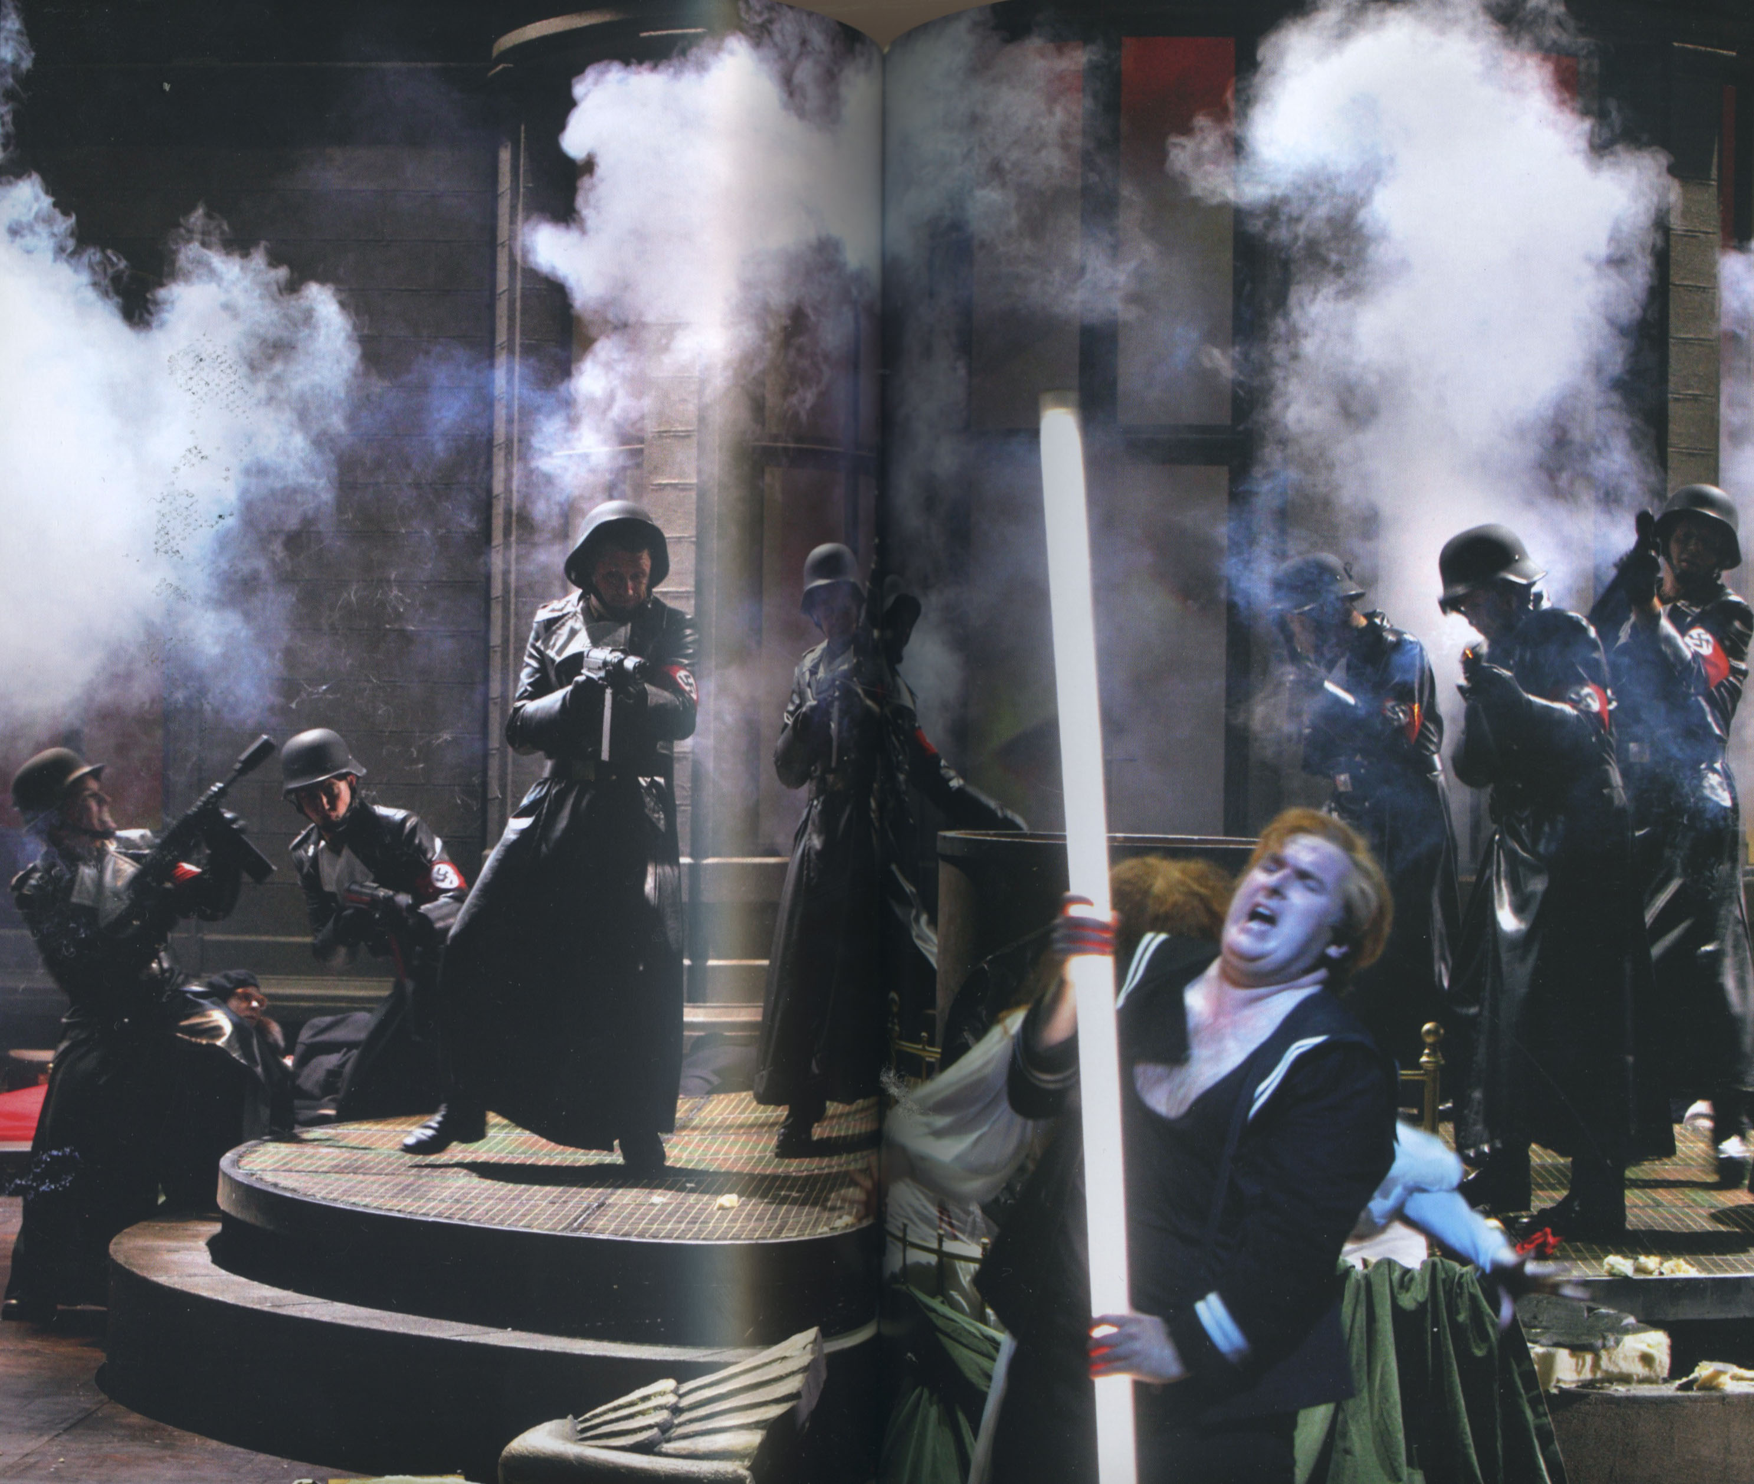

And later, in a chilling moment for the German audience, 6 huge red Nazi flags with swastikas were unfurled onstage. Traditionally the Knights are depicted as reverent monks protecting the Christian relic due to their unshaking belief in a single truth. The music I had often heard as a noble hymn to sacred honor, now became something threatening and militant. The lines between belief and tyranny are vague.

You might have seen the image of the eagle that was adopted by the Nazi party as their National emblem.
It appears in many forms throughout the opera in the dress of several characters, including most notably the seductress Kundry, who periodically wear magnificent wings. (Nazi party as seductress?)
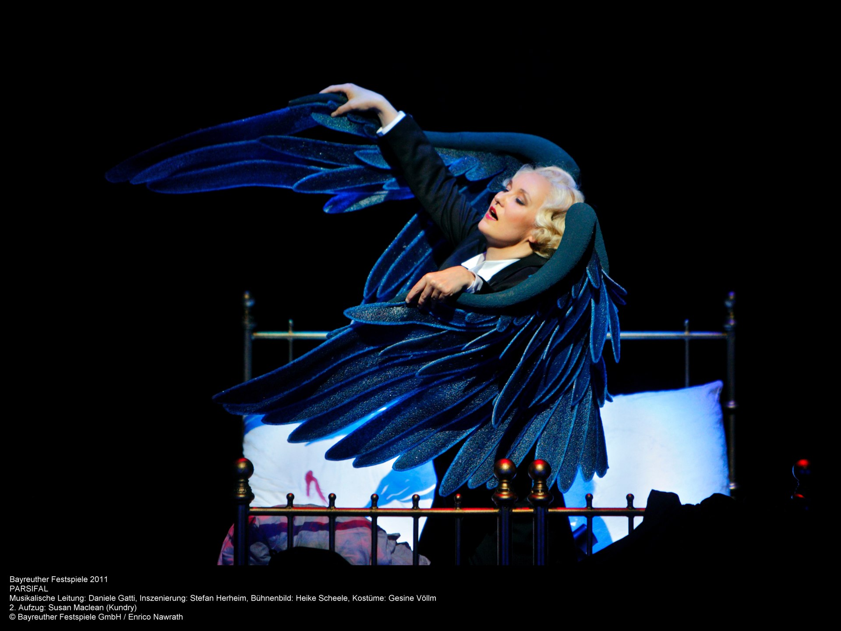
And later, as WWII images are projected onstage, the Nazi Eagle suspended over the stage crashes to the ground with a deafening sound, breaking into a hundred pieces.

Modern devices such as video projection are also used at Bayreuth. At one point in the opera, actual war footage is shown. Over these war images was projected the sentence, “Hier gilt’s der Kunst” (Art rules here). This was a slogan used by the Wagner family on posters at every festival after the war to indicate that politics were not to be discussed. This of course was something of a gag order, given Bayreuth’s embarrassing political past. So this Parsifal production, with its open discussion of that history, and dismissal of the slogan, is not only an indication of the maturation of Bayreuth but perhaps an attempt to heal the wounds of Germany itself.

Parsifal returns to Montsalvat at the beginning of Act III after all his wanderings; he has grown up. He has shed his boy-sailor’s suit in favor of the traditional Knight’s armor, as if he has been transplanted from a 19th century version of Parsifal. Removing his armor, he appears in the purity of all white (another Christ figure), with the spear that will heal the wound that will not heal and restore power and vitality to the Knights of the Holy Grail.
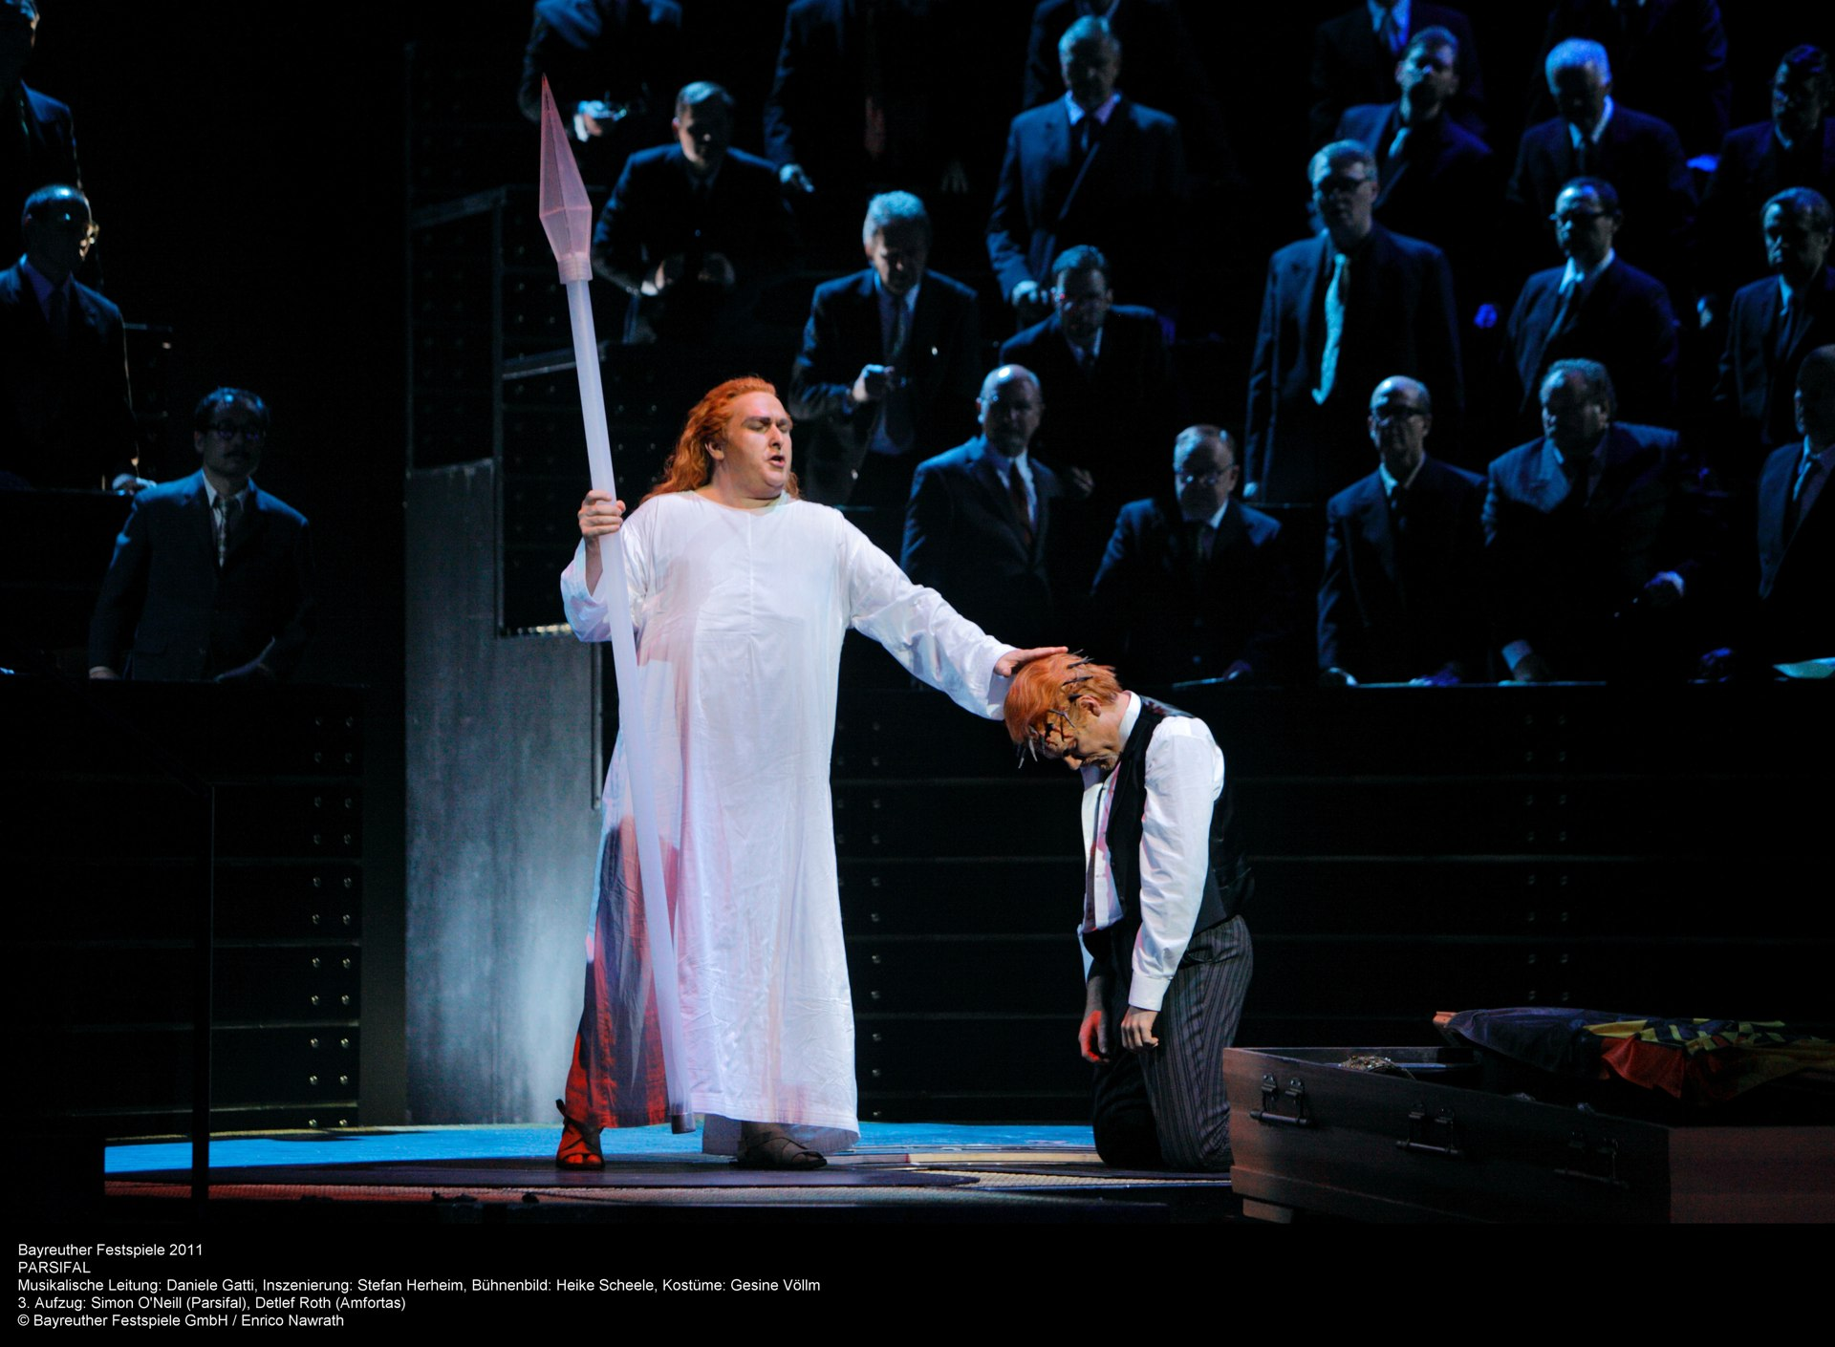

As Parsifal brings about the resurrection of Montsalvat, a small fountain begins to flow onstage, a strangely moving moment amidst the destruction. Water is indeed a powerful symbol to contemplate for its spiritual qualities.

Near the end of the opera the knights have become German government bureaucrats seated in the Bundestag. A huge round mirror suspended above the stage reflects the bright red Nazi emblem on the floor, and Parsifal is subsumed down into it.

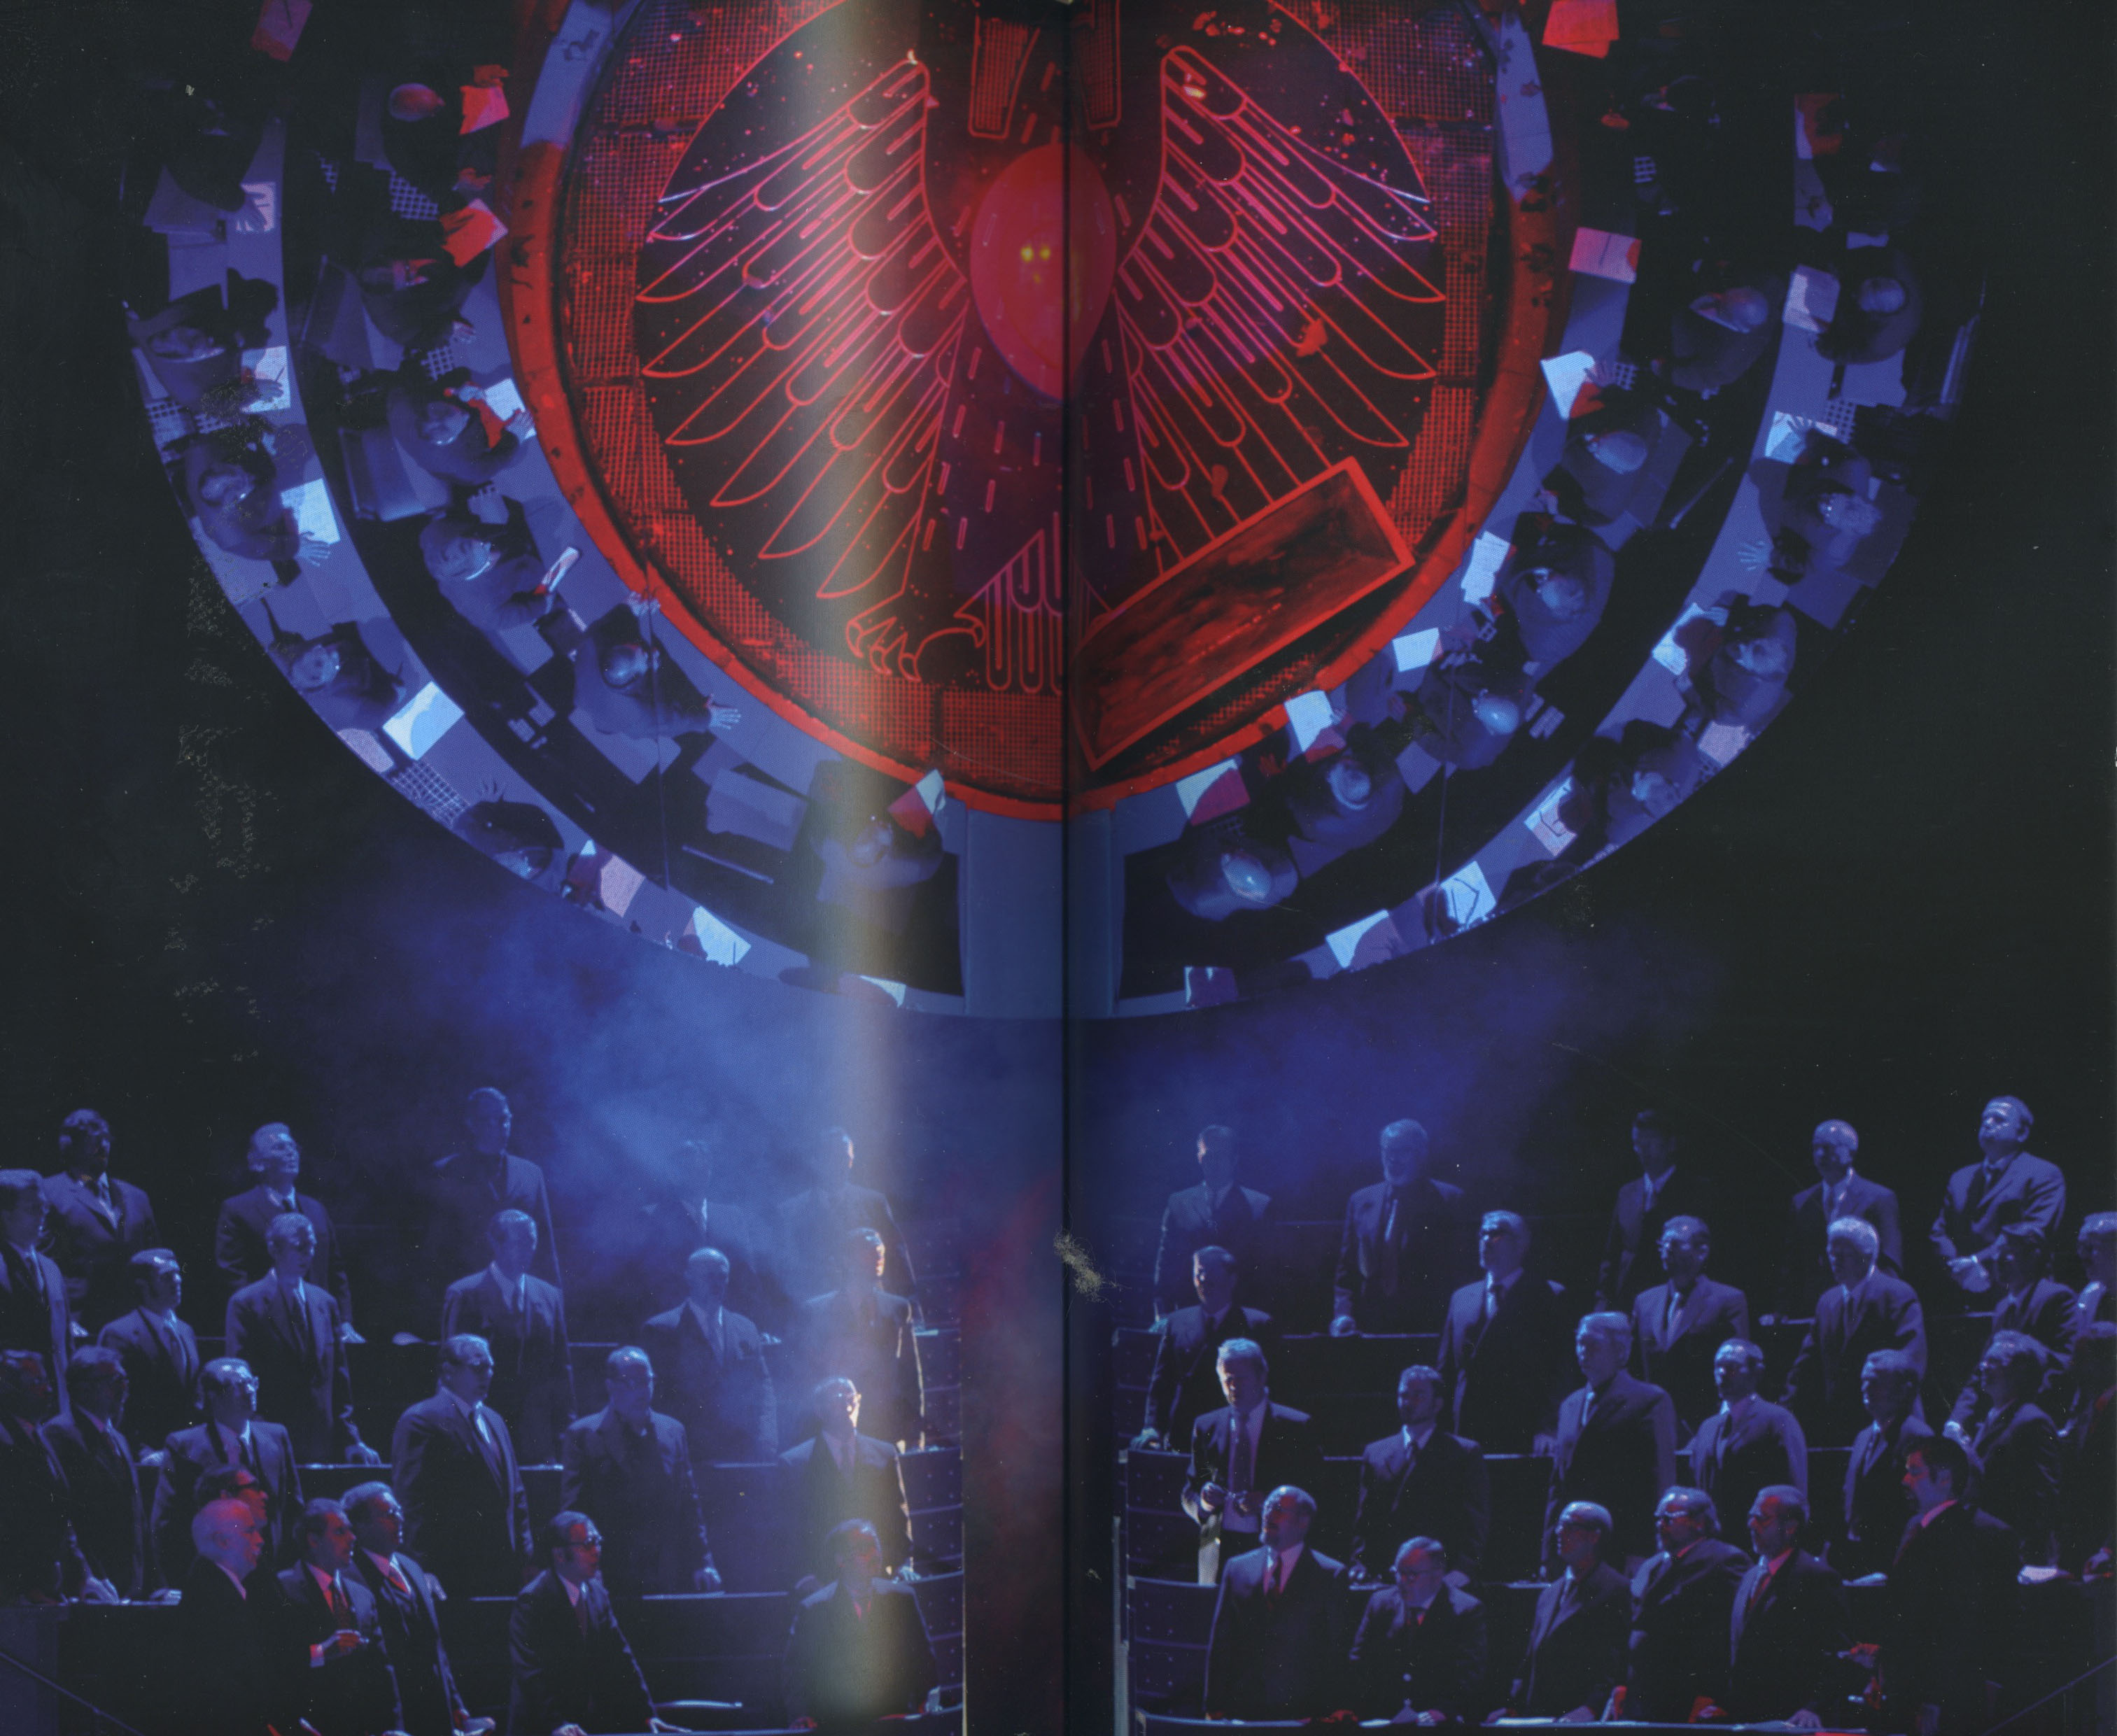

The mirror with the emblem gradually becomes a slowly turning globe…. Then it begins to tilt slowly toward the audience……And in the most stunning theatrical moment I have ever witnessed, the audience itself comes slowly into view in the mirror. You literally see yourself onstage. We become a part of the opera because, again, it is our story. We are all indicted; we all participate in the genocide; we all struggle toward the sacred……...And we are all part of the solution.

In the Bayreuth program booklet is a quote from the Bible that sums up much of Parsifal:

When I was a child, I spoke as a child, I understood as child, I thought as a child: But when I became a man I put away childish things. For now we see through a glass, darkly; but then face to face: now I know in part; but then shall I know even as also I am known.

First Epistle to the Corinthians

Conclusion

Ultimately, this is an archetypal story of the maturing the human spirit. The search for the grail is the aspect of life that will put us in touch with our true selves, our grown-up selves. If we are to find a solution to the utterly confounding problems we face as a modern society, it must come through this Wagnerian questing for spiritual maturity. The Parsifal story is not just a good story. It is your story and mine, and ours. Wagner tells us that we indeed are part of the problem and the only hope for a solution comes with healing our own wounds. No real-life Parsifal or savior is going to do it for us.

The experience of hearing and seeing Wagner in this setting at Bayreuth changed me. The juxtaposition of humankind’s most noble artistic utterances and our unending capacity for utter brutality was stark and moving. As Pico Del Mirandola wrote in the Renaissance, we truly are creatures that are unformed, indeterminant, and capable of rising to the level of divinity or descending to the depths of depravity. History has shown us that both possibilities are inherently human and found within each of us, just as they were in Wagner the genius visionary, Wagner the prophet, Wagner the fearful, egotistical man, and hateful, anti-semite.

Yes, like Bernstein I too hate Wagner……….. on my knees.

